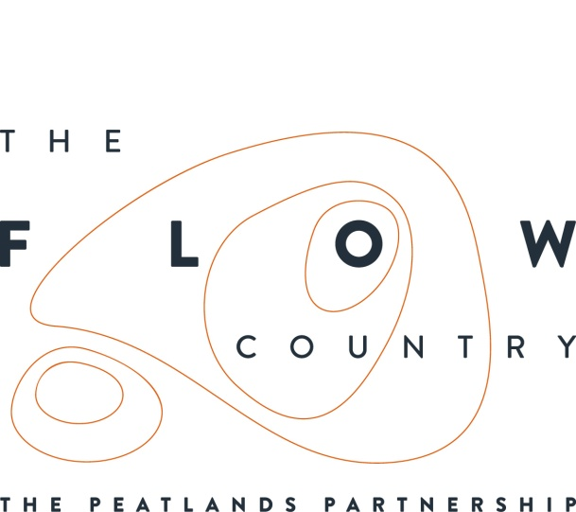

Press Release: 08/05/2017

The Flows Futureshapers: Residential weeks for 16 and 17 year olds at Forsinard

This summer, teenagers from Caithness and Sutherland have the opportunity to take part in residential weeks that will help them shape the future, both locally and globally. The Flows to the Future project is launching two Flows Futureshapers weeks in July 2017, for young people aged 16 and 17. Registration is now open, and is for all young people of this age living in Sutherland and Caithness. They can sign up for the week taking place from 14 to 20 July, or the week from 21 to 27 July.

A range of workshops will be delivered by local youth workers, guests from national organisations, Young Scot, MoveActDo, and other social action experts. These will promote skills development, confidence building, climate awareness and planning for community action. Activities will also include team building games, documentary screenings, and outdoor sessions.

These weeks offer a great opportunity for young people who would like to spend some time with peers planning a local social action project, for the benefit of the local community as well as the environment. The week is geared towards global warming issues, and how we can take action to raise awareness and do something ourselves.

The Flows Futureshapers weeks will take place at Forsinard, set amidst the Flow Country peatlands between Helmsdale and Melvich. The Flow Country is a large natural area of peatbog, which is vital in the defence against climate change by locking up carbon as peat.

Sjoerd Tel, Learning Development Officer for the project, explains more: “Connecting young people with the peatlands and with the greater story of global warming is very important. I believe the alarming messages such as sea level rise are not enough and I also think bringing young people out to engage in conversations and helping them take local action is very important.

By taking part in one of these weeks, they will feel empowered and equipped to engage in climate conversations in their home communities. They will also feel more confident in public engagement and event planning, and have learned about the power of grassroots action: something that is of great value, especially here in rural Scotland.”

Besides the Flows Futureshapers weeks Sjoerd also provides environmental education at schools and at the RSPB’s Forsinard nature reserve. “We also offer work experience placements. In this way, we engage local young people with peatlands and with the idea of a sustainable future.”

The project’s Heritage Lottery funding means that The Flows Futureshapers weeks can be offered for a fee of only £30 per participant. This includes accommodation at the Flows Field Centre in Forsinard, food, and all activities. To sign up, e-mail sjoerd.tel@rspb.org.uk and for more information you can also call Sjoerd on 079 1277 4587 or look up the details on http://www.theflowcountry.org.uk/news.

NOTES TO EDITORS
The Peatlands Partnership includes Scottish Natural Heritage, Forestry Commission (Scotland), Highland Council, RSPB Scotland, Plantlife Scotland, Highlands & Islands Enterprise, The Highland Third Sector Interface, The Flow Country Rivers Trust, The Northern Deer Management Group and The Environmental Research Institute. It liaises with local community groups, , the Scottish Government’s Rural Payments and Inspections Directorate and the North Sutherland Community Forest Trust. It is independently chaired by John Henderson of Scrabster Farm, Caithness.
RSPB Scotland is the lead partner in The Flows to the Future project, a Peatlands Partnership project, which gratefully acknowledges funding from the Heritage Lottery Fund and from the following funders and supporters; Environmental Research Institute, European Regional Development Fund, Forestry Commission (Scotland), Peatland Action, Highlands and Islands Enterprise, The Highland Council, RSPB, WREN, Scotland Rural Development Programme, Scottish Government, Scottish Natural Heritage and The Tubney Trust.

CONTACT DETAILS
Alan Tissiman RSPB Public Affairs Manager can be contacted on 01463 228810 or 07775 227614 or alan.tissiman@rspb.org.uk
Caroline Eccles Project Manager - Flows to the Future Project, working on behalf of The Peatlands Partnership, c/o North Scotland Regional Office, Inverness. 01463 715000, Mobile 07590 441475 or caroline.eccles@rspb.org.uk
Ian Mitchell, Secretary, The Peatlands Partnership, c/o Scottish Natural Heritage: Tel 01408 634063 or peatlands_partnership@snh.gov.uk

