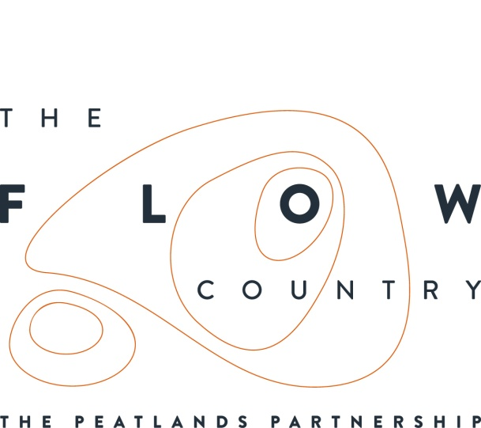

Press Release: 04/01/2017

Peat creel needed for new display at Strathnaver Museum

A new display at Strathnaver Museum in Bettyhill will be telling the story of peat cutting, using tools and objects from the museum’s collection. One key part of the story is missing however, a peat creel, ideally one with a connection to the area. We would like to hear from anyone who could loan or donate a peat creel to the museum.

The new display will completely refresh the part of the museum looking at peat cutting. It will tell the story of the importance of cutting and burning the peats as part of community and family life in Sutherland. There will also be information highlighting the importance of the peatlands in the local area for wildlife and as a carbon store.

The Heritage Lottery funded Flows to the Future Project will be providing new displays and information at a number of locations across Caithness and Sutherland. This is to ensure that residents and visitors to the area, can easily find out more about the Flow Country peatlands and their international importance.

Rosemary Macintosh from Strathnaver Museum said “We are delighted to get this opportunity to create a new display of our peat collection and hopefully gather some new ‘tales from the hill’. We have a great selection of peat cutting tools, all kindly donated by local people, but no peat creel basket...if we could source one locally it would really add to the final display”.

If you think you might be able to help with the loan of a peat basket for Strathnaver Museum please contact Rosemary on 01641 521418 or info@strathnavermuseum.org.uk.

The new displays at the museum will be completed over the winter and will be opened in April when the museum re-opens for the season.

PHOTOGRAPH: Peat creels being used to transport the peats home. Copyright Gairloch Museum and Archive.

NOTES TO EDITORS
The Peatlands Partnership includes Scottish Natural Heritage, Forestry Commission (Scotland), Highland Council, RSPB Scotland, Plantlife Scotland, Highlands & Islands Enterprise, The Highland Third Sector Interface, The Flow Country Rivers Trust, The Northern Deer Management Group and The Environmental Research Institute. It liaises with local community groups, the Scottish Government’s Rural Payments and Inspections Directorate and the North Sutherland Community Forest Trust.
RSPB Scotland is the lead partner in The Flows to the Future project, a Peatlands Partnership project, which gratefully acknowledges funding from the Heritage Lottery Fund and from the following funders and supporters; Environmental Research Institute, European Regional Development Fund, Forestry Commission (Scotland), Peatland Action, Highlands and Islands Enterprise, The Highland Council, RSPB, WREN, Scotland Rural Development Programme, Scottish Government, Scottish Natural Heritage and The Tubney Trust.

CONTACT DETAILS
Alan Tissiman RSPB Public Affairs Manager can be contacted on 01463 228810 or 07775 227614 or alan.tissiman@rspb.org.uk
Caroline Eccles Project Manager - Flows to the Future Project, working on behalf of The Peatlands Partnership,Tel. 07590 441475 or caroline.eccles@rspb.org.uk
Ian Mitchell, Secretary, The Peatlands Partnership, c/o Scottish Natural Heritage: Tel 01408 634063 or peatlands_partnership@snh.gov.uk

