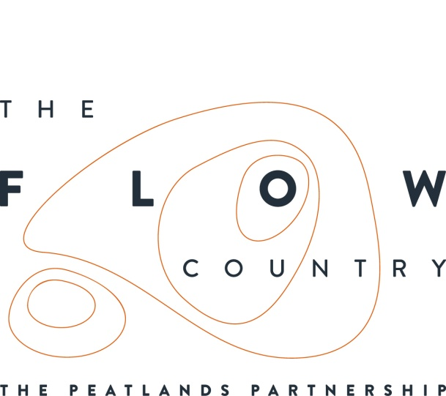

Press Release: 14/08/17

New Flow Country exhibition launched at Caithness Horizons Museum.

On Saturday 12 August, a new Flow Country exhibition was opened at Caithness Horizons Museum in Thurso. The exhibition is part of the Peatlands Partnership’s Heritage Lottery funded Flows to the Future project and was developed in collaboration with the museum. The new display highlights the importance of the Flow Country peatlands for both wildlife and people, including the bog’s ability to store a vast amount of carbon. As well as stunning imagery, the exhibition includes the new Flow Country films, a 3D digital landscape model and a carbon capture computer game. There are also floor jigsaws and fantastic new dressing up costumes which allow children to become a creature of the flows.

A key element of the exhibition is the children’s illustrations that decorate the glass stair case in the main exhibition room. Curator Joanne Howdle said, ‘Members of Caithness Horizons Museum's Peter's Pals: Young Curators Club were delighted to see their artwork unveiled as part of the new Flow Country exhibition. The children had been given the wonderful opportunity by the Flows to the Future Project to contribute their interpretation of Flow Country plants and animals to the new exhibition. This project, which involved young people in the design of the new exhibition, was cross-organisation community engagement at its best.'

The new exhibition is a permanent feature at the museum and is available to see daily. It is just one way that the project is connecting people with this precious and important landscape. New exhibitions are also in place at RSPB Scotland’s Forsinard Flows visitor centre (on the road that links Melvich to Helmsdale) and at Strathnaver Museum in Bettyhill.

For details about future events and to find out more about peatlands visit the Flow Country website www.theflowcountry.org.uk, or find the Flow Country on facebook and twitter.

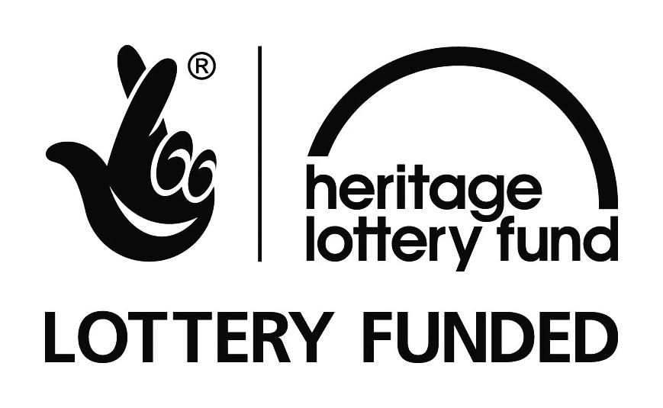

Photograph:
DSC_0173 Officially opening the exhibition with a member of the Peter’s Pals Young Curators Club. Copyright - RSPB
DSC_02016 – Playing the Carbon Capture Computer Game Copyright - RSPB
DSC_0219 – Dressed as a Dragonfly completing craft activities as part of the event. Copyright - RSPB

NOTES TO EDITORS
The new Flows Field Centre is located at Forsinard on RSPB’s Forsinard Flows Nature Reserve, part of which received the accolade of being designated as a National Nature Reserve by Scottish Natural Heritage in September 2016
The Peatlands Partnership includes Scottish Natural Heritage, Forestry Commission (Scotland), Highland Council, RSPB Scotland, Plantlife Scotland, Highlands & Islands Enterprise, The Highland Third Sector Interface, The Flow Country Rivers Trust, The Northern Deer Management Group and The Environmental Research Institute. It liaises with local community groups, , the Scottish Government’s Rural Payments and Inspections Directorate and the North Sutherland Community Forest Trust. It is independently chaired by John Henderson of Scrabster Farm, Caithness.
RSPB Scotland is the lead partner in The Flows to the Future project, a Peatlands Partnership project, which gratefully acknowledges funding from the Heritage Lottery Fund and from the following funders and supporters; Environmental Research Institute, European Regional Development Fund, Forestry Commission (Scotland), Peatland Action, Highlands and Islands Enterprise, The Highland Council, RSPB, WREN, Scotland Rural Development Programme, Scottish Government, Scottish Natural Heritage and The Tubney Trust.

CONTACT DETAILS
Alan Tissiman RSPB Public Affairs Manager can be contacted on 01463 228810 or 07775 227614 or alan.tissiman@rspb.org.uk
Caroline Eccles Project Manager - Flows to the Future Project, working on behalf of The Peatlands Partnership, c/o North Scotland Regional Office, Inverness. 01463 715000, Mobile 07590 441475 or caroline.eccles@rspb.org.uk
Ian Mitchell, Secretary, The Peatlands Partnership, c/o Scottish Natural Heritage: Tel 01408 634063 or peatlands_partnership@snh.gov.uk

