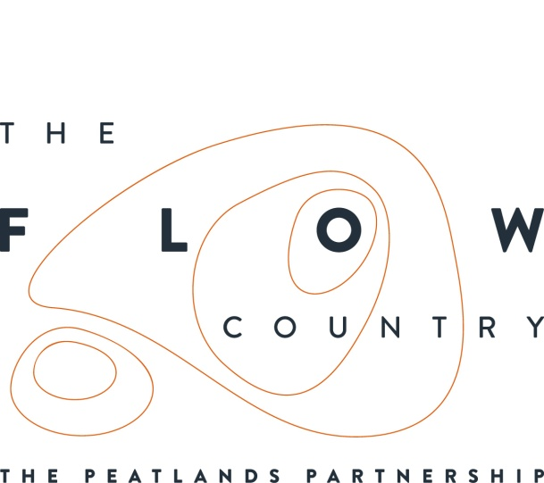

Press Release: 06/02/2017

Flows Photography at Forsinard

On Saturday 20th January Thurso Camera Club visited the RSPB Forsinard Flows Reserve to find out more about The Flow Country and see some of the peatland restoration work in action. The club were led by staff and volunteers from the Flows to the Future Project, RSPB Scotland and the Environmental Research Institute, University of the Highlands and Islands.

The group left Forsinard in thick fog but after climbing up further into the reserve they were rewarded with a temperature inversion that locked warm humid air in the valley and provided incredible vistas, with clouds spilling over Knockfin Heights and cloaking the flows in ethereal light. They visited the restoration sites where forestry is being removed from areas of deep peat to enable the return of specialist peatland plants and wildlife.

Bob Murdoch from the Camera Club said, ‘The members thoroughly enjoyed their visit to Forsinard to find out more about the Flow Country and the work going on to restore the peatlands. Members have been inspired to return to the Flow Country to try and capture the wide variety of landscapes and habitats in their varying seasons and moods'

The visit was the start of a project that will result in a photography exhibition at the Flow Country conference in March being organised by the Environmental Research Institute in Thurso. The exhibition will form part of the ‘Poster & Taster’ Session on Wednesday 22nd March and is open to the public.

The Flow Country Conference will be taking place in Thurso from March 21st – 24th at Thurso Cinema and North Highland College. Visit www.eri.ac.uk for more information.

You can find out more about what is happening across The Flow Country by looking at our website at www.theflowcountry.org.uk or joining us on facebook (The Flow Country) or twitter (@theflowcountry).

.

Photograph 1: Looking out across the inversion – Copyright Ben Hinder
Photograph 2: A lesson from the experts – Copyright Ben Hinder
Photograph 3: Landscape photography in the flows – Copyright Ben Hinder

NOTES TO EDITORS
The new Flows Field Centre is located at Forsinard on RSPB’s Forsinard Flows Nature Reserve, part of which received the accolade of being designated as a National Nature Reserve by Scottish Natural Heritage in September 2016
The Peatlands Partnership includes Scottish Natural Heritage, Forestry Commission (Scotland), Highland Council, RSPB Scotland, Plantlife Scotland, Highlands & Islands Enterprise, The Highland Third Sector Interface, The Flow Country Rivers Trust, The Northern Deer Management Group and The Environmental Research Institute. It liaises with local community groups, , the Scottish Government’s Rural Payments and Inspections Directorate and the North Sutherland Community Forest Trust. It is independently chaired by John Henderson of Scrabster Farm, Caithness.
RSPB Scotland is the lead partner in The Flows to the Future project, a Peatlands Partnership project, which gratefully acknowledges funding from the Heritage Lottery Fund and from the following funders and supporters; Environmental Research Institute, European Regional Development Fund, Forestry Commission (Scotland), Peatland Action, Highlands and Islands Enterprise, The Highland Council, RSPB, WREN, Scotland Rural Development Programme, Scottish Government, Scottish Natural Heritage and The Tubney Trust.

CONTACT DETAILS
Alan Tissiman RSPB Public Affairs Manager can be contacted on 01463 228810 or 07775 227614 or alan.tissiman@rspb.org.uk
Caroline Eccles Project Manager - Flows to the Future Project, working on behalf of The Peatlands Partnership, c/o North Scotland Regional Office, Inverness. 01463 715000, Mobile 07590 441475 or caroline.eccles@rspb.org.uk
Ian Mitchell, Secretary, The Peatlands Partnership, c/o Scottish Natural Heritage: Tel 01408 634063 or peatlands_partnership@snh.gov.uk

