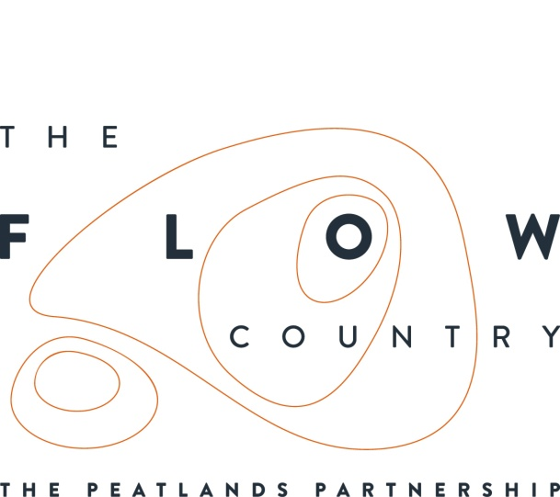

Press Release: 16 June 2017
Exciting volunteer opportunities available across the Flow Country

The Flows to the Future Project and RSPB Scotland have opportunities available for local volunteers to assist with their vital work in the internationally important Flow Country peatlands.

Volunteering is a great way of getting outdoors, making a difference, meeting like-minded people, and experiencing the habitat and wildlife of Europe’s largest blanket bog.

The Flows to the Future project has two roles available: a Learning Assistant and a Community Engagement volunteer. Both will be working to increase awareness of the Flow Country including its value as a carbon store and as a habitat for specialist peatland species.

The Learning Assistant will help deliver educational activities to schools at RSPB Forsinard and at other peatland sites, and schools across Caithness and Sutherland. Volunteers will gain valuable experience of working with children and young people, and in environmental education.

The Community Engagement volunteer will be raising awareness of the Flow Country by assisting with events and projects across Caithness and Sutherland. Inspiring and engaging communities with peatlands will help gain support for essential conservation work and provide experience in event management, PR and marketing, and working with a wide range of groups.

RSPB Forsinard is looking for Conservation Work Party volunteers to work on the reserve completing a variety of hands-on tasks that conserves the peatlands habitat and maintains the reserve. These include removing invasive regenerating conifer trees, blocking drains out on the open hill, and maintaining visitor trails.

A work party taster day is running on the 29th June, and is open to anyone interested. The reserve can easily be reached by train from Thurso and is between Helmsdale and Melvich.

Claire Foot-Turner, Warden at RSPB Forsinard says, “Our work party taster day is a great way for people to discover more about volunteering with us. It will give people a chance to see the work we do on the reserve, as well as experience the Flow Country alongside other volunteers, and decide if the role is for them.”

No experience is needed to volunteer, but if you have existing skills, that is always useful. If you would like to find out more about the work party taster day or the roles in more detail, please contact Claire Foot-Turner at Claire.foot@rspb.org.uk / 01641761324 or visit http://www.theflowcountry.org.uk/volunteering/

PICTURE CREDIT : Lorne Gill, SNH

NOTES TO EDITORS
The Peatlands Partnership includes Scottish Natural Heritage, Forestry Commission (Scotland), Highland Council, RSPB Scotland, Plantlife Scotland, Highlands & Islands Enterprise, The Highland Third Sector Interface, The Flow Country Rivers Trust, Highlands and Island Enterprise, The Northern Deer Management Group and The Environmental Research Institute
RSPB Scotland is the lead partner in The Flows to the Future project, a Peatlands Partnership project, which gratefully acknowledges funding from the Heritage Lottery Fund and from the following funders and supporters; Environmental Research Institute, European Regional Development Fund, Forestry Commission (Scotland), Peatland Action, Highlands and Islands Enterprise, The Highland Council, RSPB, WREN, Scotland Rural Development Programme, Scottish Government, Scottish Natural Heritage, The Banister Trust and The Tubney Trust.

CONTACT DETAILS
Alan Tissiman RSPB Public Affairs Manager can be contacted on 01463 228810 or 07775 227614 or alan.tissiman@rspb.org.uk
Caroline Eccles Project Manager - Flows to the Future Project, working on behalf of The Peatlands Partnership,Tel. 07590 441475 or caroline.eccles@rspb.org.uk
Ian Mitchell, Secretary, The Peatlands Partnership, c/o Scottish Natural Heritage: Tel 01408 634063 or peatlands_partnership@snh.gov.uk

