Monday, 7th August 2017  Environment Secretary Roseanna Cunningham opens a new centre for volunteering and research and finds out about the work of the Peatlands Partnership. | 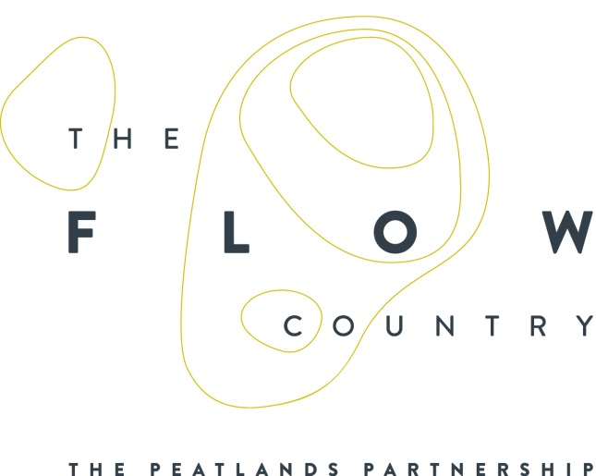

PRESS RELEASE

A new volunteering and research centre was opened today (Mon 7 Aug) by the Cabinet Secretary for Environment, Climate Change and Land Reform, Roseanna Cunningham, as part of her visit to the Peatlands Partnership in Forsinard, Sutherland

The Flows Field Centre is one of the key outputs of the Partnership’s £10.6 million Flows to the Future Project and is situated on RSPB’s Forsinard Flows National Nature Reserve. The Field Centre, which cost around £2 million, is situated in the heart of The Flow Country and was completed in the autumn of 2016 by a local Caithness based building firm.

After a tour of the Field Centre and a chance to meet members of the Peatlands Partnership members, staff, and volunteers working on the RSPB Forsinard Flows reserve, Ms Cunningham explained:

“I’m delighted to be here to officially open this new, state-of-the-art centre, which should allow for further research, and therefore greater understanding of how we can best preserve these vital peatlands, and ensure it has a long term sustainable future. The centre will also provide a much needed base for increasing the numbers of volunteers carrying out important conservation work in this area.

It’s been great to visit the Partnership and meet in person the many members of staff and volunteers whose enthusiasm and experience are vital to the project’s aims. I’m sure they are all very excited to have the use of this new facility, which will allow them to build on the excellent work they already do in educating the public on the importance of these peatlands in fighting against the effects of climate change.

All of us have a responsibility to make sure that this fascinating land, with its rich biodiversity and traditional culture, remains healthy, actively storing carbon and providing sustainable economic benefits for local people”.

Welcoming Ms Cunningham, Peatlands Partnership Chairman, Professor Stuart Gibb of the Environmental Research Institute in Thurso, Caithness, explained:

“15% of all the blanket bog in the world is in Scotland. We therefore play a key role in conserving this globally rare habitat. Not only is The Flow Country important for the amount of blanket bog that can be found here, but the quality of the peatland is also world class as has been clearly demonstrated by the fact that this amazing area is on the UK’s Tentative List of possible World Heritage Sites.

“But let’s not forget that these bogs are not just important for nature and wildlife; they provide vital services for people too. They store more carbon than any other land-based ecosystem, making them a vital defence against the effects of climate change.

We are all delighted to welcome the Cabinet Secretary for Environment, Climate Change and Land Reform here today to have an opportunity to show her what we are all doing to help study, restore, manage and promote the wonders of the Flow Country.”

The new Field Centre, which also serves as the Reserve Office for RSPB (Scotland) who are the lead partners in the Flows to the Future Project, will allow for a significant increase in volunteering opportunities both on the RSPB’s reserve and elsewhere in Caithness and Sutherland. It provides accommodation for short-term and long-term volunteers as well as providing accommodation for visiting groups of up to 16 people.

The Centre also helps support the establishment of a peatland science centre of excellence at the Environmental Research Institute in Thurso, through the provision of a small laboratory and accommodation for students to do research into the role of peatlands as a carbon store and on peatland restoration and biodiversity. This will help develop links with a number of universities around the world to further research and international collaboration.

The Heritage Lottery Fund is the largest individual funder of the Flows to the Future project contributing over £4 million.

Also welcoming Ms Cunningham to Forsinard was Lucy Casot, Head of the Heritage Lottery Fund Scotland, who said:

“The Flow Country is an area of exceptional natural heritage merit. Over 8,000 years of the history of plants, weather and people lie preserved in its layers of peat. Yet this living landscape is as important to our future as it is to our heritage. Thanks to players of the National Lottery, we welcome this Centre of Excellence which, through the dedicated work of staff and volunteers, will make an important contribution to the global climate change agenda.”

In formally declaring the Flows Field Centre open, Ms Cunningham acknowledged the continuing work of the Peatlands Partnership and RSPB in protecting and restoring significant areas of The Flow Country as well as delivering sustainable economic benefits through the creation of high quality visitor facilities across Sutherland and Caithness.

“You have come a long way from the EU LIFE projects of over 10 years ago” Ms Cunningham said. “The legacy and economic benefits that the current Flows to the Future project will deliver is another excellent step on the way to fulfilling our ambition to see the Flow Country inscribed as a UNECSO World Heritage Site.”

Ends.

Press photos of the event are available from the following contacts:

CONTACT DETAILS

- Caroline Eccles, Project Manager - Flows to the Future Project, 01463 715000, Mobile 07590 441475
caroline.eccles@rspb.org.uk

- Alan Bannon: Scottish Government Press Office 0131 244 9573
Alan.Bannon@gov.scot

- Alan Tissiman RSPB Public Affairs Manager 01463 228810 or 07775 227614 alan.tissiman@rspb.org.uk

- Ian Mitchell, Secretary, The Peatlands Partnership, c/o Scottish Natural Heritage: Tel 0300 0673110
peatlands_partnership@snh.gov.uk

Notes for Editors:

THE PEATLANDS PARTNERSHIP includes Scottish Natural Heritage, RSPB Scotland, The Highland Council, The Environmental Research Institute (University of the Highlands and Islands), Forestry Commission (Scotland), Plantlife International, Highland Third Sector Interface, the Flow Country Rivers Trust, Northern Deer Management Group and Highlands and Islands Enterprise. It is chaired by Professor Stuart Gibb of the Environmental Research Institute/University of the Highlands and Islands.

The Peatlands Partnership was formed at the end of 2006 following the completion of the EU LIFE funded Peatlands Project and aims to develop and build on that project. The Partnership comprises 'core' organisations, together with other interested organisations and individuals, who will carry out and support the objectives set out in the Management Strategy document, 'The Peatlands of Caithness and Sutherland'.

The Partnership operates over the whole of Sutherland and Caithness and includes the internationally important blanket bog area known as The Flow Country.
The current activities of the Partnership include:
- Delivering the Flows to the Future project,
- Revision of the Peatlands Management Strategy,
- Acting as a forum for discussing issues relating to peatlands and peatland management, and
- Taking forward the possible UNECSO inscription of The Flow Country as a World Heritage Site.

The Flow Country
The Flow Country is an area of deep peat, dotted with bog pools, that blankets much of Caithness and Sutherland. The Flow Country is the largest expanse of blanket bog in Europe and covers about 200,000 hectares. A recent academic study has described The Flow Country as being “the best peatland of its type in the world”. The Flow Country is on the UK’s tentative list for potential UNESCO World Heritage Sites.

Blanket bog only forms in cool places with plenty of rain. The few plants that can grow here such as bog mosses, don’t rot away, but build up to form deep layers of peat. The Flow Country’s bogs have been growing for over 10,000 years, ever since the glaciers melted away at the end of the last Ice Age, and the peat is now over 10 metres deep in places.

This accumulated peat importantly stores about 400 million tonnes of carbon. Only active healthy bogs can lock up carbon in peat and so many areas damaged in the past by inappropriate land management such as commercial afforestation are now being restored back to healthy bog habitat.

The Flow Country is also internationally important as a breeding ground for birds that depend on this wild, unspoilt environment. Red-throated and black-throated divers, golden plover and greenshank nest here, while raptors like merlin, short-eared owls and golden eagles hunt over the moss and pools.

These sorts of benefits or “ecosystem services” are increasingly recognised as major contributions to the economy, and they extend beyond protecting the environment and creating valuable economic resources.
Thousands of people come to The Flow Country every year not because of its role as a defence against climate change or because it maintains good water quality, but because it offers a rare experience of wilderness, solitude and inspiration. In the words of a Scottish Government briefing paper, peatlands give us ecosystem services that “contribute to making human life both possible and worth living.”

FLOWS TO THE FUTURE is a far reaching and ambitious project which aims to significantly increase the level of conservation management and promotional activities currently being undertaken in the Flow Country.
The £10.6 million project, with over £4 million of support from the Heritage Lottery Fund, is aiming to restore areas of blanket bog in the heart of the Flow Country that have been damaged by forestry planting. It will also promote and develop our knowledge about the role of peat and carbon storage, and involve and connect people everywhere with this precious habitat, delivering real economic benefits for one of the least densely populated areas in Scotland.

The project started on 4 July 2014 and will continue over 5 years. It is being delivered by a core Steering Group of Peatland Partnership members – Highland Council, Scottish Natural Heritage, Environmental Research Institute (UHI), and with RSPB (Scotland) as the lead partner.

Project outputs, in addition to the building of the new Flows Field Centre include the following:

- The project is restoring 7 square miles of blanket bog habitat – removing forestry blocks, crushing brash and blocking furrows in areas where forestry has already been felled, and drain blocking, on RSPB Forsinard Flows National Nature Reserve (NNR).

- We are developing five roadside interpretation sites across the Flow Country to give panoramic views of the peatlands and provide a trail for visitors and local people to experience and learn about the peatlands.

- The project has updated and improved the visitor centre at Forsinard Flows NNR and is providing improved parking and upgraded interpretation on the NNR’s Dubh Lochan Trail.

- The project will be creating improved and increased access for walkers as well as developing novel and innovative interpretation and learning opportunities for people across the Flow Country.

- We have developed a successful schools’ learning programme and a 5 year programme of community activities both at Forsinard and throughout Caithness and Sutherland.

- We have created a 6m high viewing tower – the architectural award winning “Flows Lookout” – and an easy access boardwalk along a Dubh Lochan Trail at Forsinard.

- For those unable to visit the Flow Country the project has developed remote learning and awareness raising opportunities through; an interactive website, a documentary film, an online 3D landscape model of the Flow Country and an exciting carbon capture computer game.

- To engage with new audiences we have developed some creative community arts commissions to encourage people to engage with the Flows through the arts.

- A UK wide travelling exhibition about carbon and peatlands was launched by The Peatlands Partnership at the Royal Botanic Gardens in Edinburgh in June.

