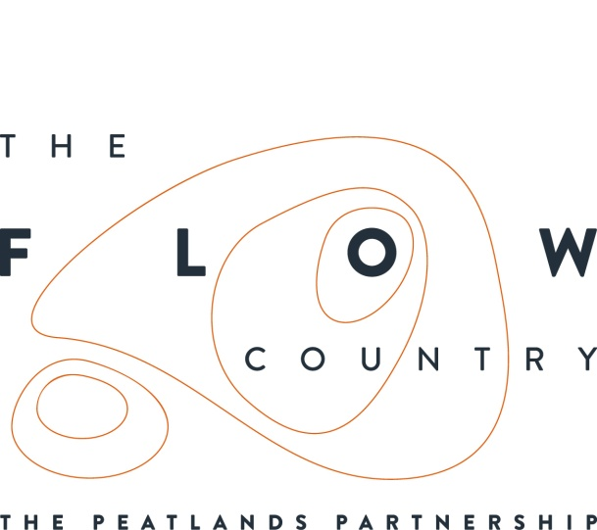

For immediate use

Press Release: The Flow Country comes to Inverness

A major exhibition opens on 12 January for two weeks only at Inverness College UHI focussing on the Flow Country, one of Europe’s last wild places. The Flow Country is not that far from Inverness, but most of us know little about it or have not even heard of it. This is the ideal chance to find out more about this rare national treasure.

The Flow Country stretches through Caithness and Sutherland and is the best blanket bog of its type in the world. It’s also a candidate UNESCO World Heritage Site, which puts it on the same level of importance as the Taj Mahal and the Grand Canyon. It’s a place of vast inspirational landscapes, an epic backdrop to fascinating and beautiful details, from soaring hen harriers to insectivorous plants.

The area is also of key significance in Britain’s efforts to mitigate the effects of climate change. There is more carbon locked up in the peat of the Flow Country than in all the UK’s forests put together.

The Flow Country Exhibition includes a film produced by award winning Maramedia (who produced the BBC’s “Highlands – Scotland’s Wild Heart” TV series), fantastic imagery, an innovative 3D landscape model, an interactive game and children’s activities. It’s been organised as part of the Flows to the Future Project, of which RSPB Scotland is the lead partner, along with The Highland Council, Environmental Research Institute (UHI) and Scottish Natural Heritage.

There’s a special session for families about the fantastic beasts of the Flow Country on Saturday 12 January from 10 until 1. It’s a free drop in session with craft activities for children aged 4 to 10 who must be accompanied by an adult.

The exhibition is free and will be in the Atrium and second floor foyer. It will be open from 8am until 9pm Mondays to Thursdays, 8am to 7pm Fridays, 10am to 1pm Saturdays, but closed on Sundays. For more information see www.theflowcountry.org.uk/

Inverness College UHI at Inverness Campus is easily accessible with details available at the following web address: http://www.invernesscampus.co.uk/get-there/

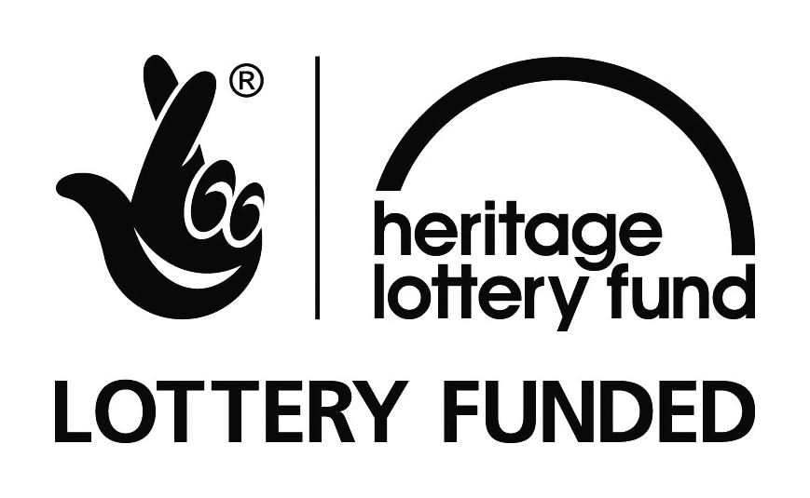

NOTES TO EDITORS
IMAGERY WILL BE SENT SEPARATELY VIA WETRANSFER
The Peatlands Partnership includes Scottish Natural Heritage, Forestry Commission Scotland, The Highland Council, RSPB Scotland, Plantlife Scotland, Highlands & Islands Enterprise, The Highland Third Sector Interface, The Flow Country Rivers Trust, and The Environmental Research Institute (UHI).
RSPB Scotland is the lead partner in The Flows to the Future project, a Peatlands Partnership project, which gratefully acknowledges funding from the Heritage Lottery Fund and from the following funders and supporters: Environmental Research Institute, European Regional Development Fund, Forestry Commission (Scotland), Peatland Action, Highlands and Islands Enterprise, The Highland Council, RSPB, WREN, Scotland Rural Development Programme, Scottish Government, Scottish Natural Heritage and The Tubney Trust.

CONTACT DETAILS
Caroline Eccles Project Manager - Flows to the Future Project, working on behalf of The Peatlands Partnership, c/o North Scotland Regional Office, Inverness. 01463 715000, Mobile 07590 441475 or caroline.eccles@rspb.org.uk
Ian Mitchell, Secretary, The Peatlands Partnership, c/o Scottish Natural Heritage: Tel 01463 701691 or peatlands_partnership@nature.scot

