The Flow Country (Scotland) as a blanket bog landscape -   
A global evaluation

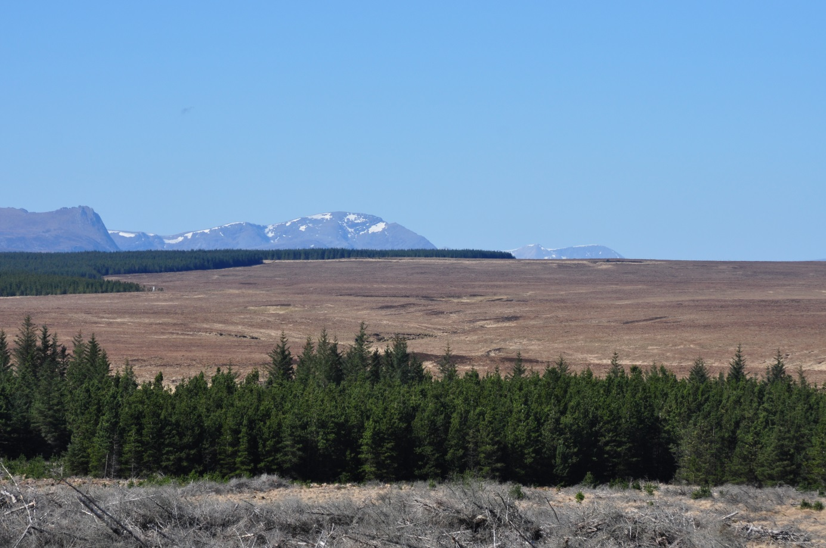

Hans Joosten1, Isabell Szallies1 & Cosima Tegetmeyer2

1Institute of Botany and Landscape Ecology, Ernst-Moritz-Arndt University Greifswald & 2Duene e.V.

Partners in the Greifswald Mire Centre

International Mire Conservation Group

Greifswald, March 2016

 

Content

Summary 2

1. Introduction 4

2. Methods 5

3. Results 6

3.1 Analysis of terms and concepts 6

3.2 Working definitions 9

3.3 Blanket bog landscapes 10

3.4 Quality comparison 16

4. Discussion 19

4.1 Definitions, identification and delineation 19

4.2 Valuation 21

5. Conclusion 22

Acknowledgements 22

References 22

# Summary

At the request of Scottish Natural Heritage, on behalf of the Flow Country Peatlands Partnership, the International Mire Conservation Group, coordinated by the Greifswald Mire Centre, made an assessment of the global importance of the Flow Country (Scotland) using the criteria ‘size’ and ‘quality’, the latter expressed as the non-degraded area. On the basis of literature, personal communications, and remote sensing, a list was compiled of ‘potential blanket bog landscapes’, which were analysed in more detail. Tropical and high mountain areas were excluded from analysis, as well as heavily forested sites.

The analysis showed that of the ‘potential blanket bog landscapes’ with a larger gross or net (undegraded) size than the Flow Country, three areas have no confirmed blanket bog occurrence (Kamchatka, North Sakhalin, South Sakhalin), two areas are strongly degraded (Central Scotland, Wales), and two sites (Falklands/Malvinas and Peninsula Mitre, both in the extreme southern hemisphere) have a fully different blanket peat forming flora. Avalon Peninsula and the Flow Country score equal in non-degraded landscape size, but the Flow Country is larger in gross size. All other areas are smaller in both gross size and high quality area than the Flow Country.

The Flow Country can thus justly be called a ‘*primus inter pares*’ of the blanket bog landscapes worldwide.

# 1. Introduction

The Flow Country of Caithness and Sutherland (Scotland, United Kingdom) is widely considered to be one of the finest examples of blanket bog landscapes worldwide (Lindsay et al 1988). In 2012 the area has been put on the ‘tentative list’ of UNESCO World Heritage Sites of the United Kingdom (<http://whc.unesco.org/en/tentativelists/state=gb>).

In an internal UK evaluation process before submission of a full application to UNESCO, the absence of an independent report on the importance of the area was noted. The Assessment Panel considered “that there was not a good existing international context in which to assess the claims [that the Flow Country was one of the largest and most intact, if not the largest and most intact, area of blanket bog in the world] though that might be developed, for example with the assistance of the International Mire Conservation Group and/or the International Peat Society. The panel thought that a case is made for a European level of importance – but not for a universal one. The comparative analysis needs strengthening and requires more clarity” (Davies 2013).

To comply with this request, Scottish Natural Heritage invited the International Mire Conservation Group (IMCG) to evaluate the global importance of the Flow Country as a blanket bog landscape, especially with respect to its size and quality. IMCG ([www.imcg.net](http://www.imcg.net)) is a worldwide network of mire scientists and managers with 650 members in 65 countries.

The present report, on behalf of IMCG was prepared by the Greifswald Mire Centre (GMC, <http://greifswaldmoor.de/home.html>), which organized and coordinated the input of a wide range of IMCG members and other experts. The report builds on the MSc thesis of Isabell Szallies (Szallies 2016). The conclusions of the report were endorsed by IMCG through decision of its Main Board of 27 March 2016.

# 2. Methods

The term ‘blanket bog’ is used with various connotations. As a first step, an analysis was made of relevant terms, concepts, definitions and descriptions, based on an extensive literature review (especially using the GMC Peatland and Nature Conservation International Library PeNCIL), the World Wide Web, and personal communications and discussions within the IMCG network. Informed by this analysis, we elaborated working definitions of ‘blanket bog’ and ‘blanket bog landscape’. These definitions were further discussed with experts both bilaterally and at the symposium ‘Research in the Flow Country: Taking Stock’ in Thurso, Caithness, 27-30 October 2015.

A list of ‘known’ blanket bog landscapes worldwide was compiled on the basis of literature (especially Lindsay et al. 1988, Tallis 1995) and personal communications, with satellite imagery (Google Earth, Bing, STRM, see below) being used to screen additional areas. The search image was inspired by the open, undulating appearance of the Scottish blanket bog landscape, as blanket bog landscapes which deviate strongly from that form (e.g. densely forested and tropical high mountain ones) have their own merit and do not compete with the Flow Country for ‘global uniqueness’. Special attention was paid to areas with a suitable climate for blanket bog formation (wet, cool). As blanket bog cannot be unambiguously identified by remote sensing, we used a set of indicators, consistent with the blanket bog definition:

* mainly ombrotrophic: derived from climate, relief (see below), and vegetation;
* peatland: derived from literature and remote sensing (e.g. typical peat extraction and erosion patterns);
* relief: derived from stratigraphical profiles and digital elevation models (cf. Chapter 3.2).

For all candidate blanket bog landscapes, information was collected on climate, geology, land form, peat distribution and stratigraphy, hydrologic system, cover and land use. In addition to literature and maps, we used satellite and aerial imagery (Google [https://www.google.de/maps?source=tldso,](https://www.google.de/maps?source=tldso,%20) Bing <https://www.bing.com/maps/>), whereas digital elevation data were derived from the Shuttle Radar Topography Mission (SRTM, 1 sec/30 resolution, <https://lta.cr.usgs.gov/SRTM1Arc>). Furthermore, an inventory worksheet was sent to IMCG members and other mire experts with regional knowledge. Potential blanket bog landscapes were studied at a scale 1:20,000 - 30,000.

The size and quality of the identified blanket bog landscapes were then semi-quantitatively assessed. This analysis was limited to areas of similar magnitude as the Flow Country: very small areas were excluded.

Maps throughout this report were created using ArcGIS® software by Esri. ArcGIS® and ArcMap™, are the intellectual property of Esri and are used herein under licence.

# 3. Results

## 3.1 Analysis of terms and concepts

The first known reference to a blanket bog is by Young (1780) who travelled from Boyle to Ballymote (Co. Sligo, Ireland):

“Crossed an immense mountainy bog, where I stopped and made enquiries. Found that it was ten miles long and three and a half over, containing thirty-five square miles; […] nothing would be easier than to drain it, vast tracts of land have such a fall, that not a drop of water could remain. These hilly bogs are extremely different from any I have seen in England. In the moors in the north, the hills and mountains are all covered with heath, like the Irish bogs, but they are of various soils, gravel, shingle, moor, etc. and boggy only in spots, but the Irish bog hills are all pure bog to a great depth, without the least variation of soil, and a bog being of a hilly form is a proof that it is a growing vegetable mass and not owing merely to stagnant water.”

Anderson (1794) described that "Most of the hills on the west coast of Scotland, and the islands of the Hebrides, have their surface entirely covered with moss”.

Lesquereux (1844) found that ‘next to peat deposits that occur where an accumulation of standing water took place, peat layers sometimes cover rounded-off mountain knolls and hang down over their sides like a coat’ (all translations by HJ).

In his overview of European bogs, Osvald (1925) recognised: ‘In areas with a more distinct atlantic climate than the one that characterises areas with real raised bogs, bogs of a fully different appearance occur. This type I have called in my treatise [i.e. Osvald 1923] the distinct atlantic bog type. The most typical representatives of this type are arguably the extensive “upland moors” on the Pennines in England. These “bogs” cover the terrain completely, including plateaus, slopes, depressions and heights; they carry a very uniform plant community, the bare *Eriophorum vaginatum* - association. […] Downward these mires pass into *Calluna* - moors and it may not be easy, if at all possible, to draw a clear boundary between these upland moors and the vigorously mor humus forming atlantic heaths. As a name for this type of mire one could choose the expression “terrainbedeckende Moore” [terrain covering mires]. Also the Scottish *Scirpus caespitosus* –bogs (Smith and Moss 1903, Moss 1913) that seem to form an analogue to the *Eriophorum vaginatum* – “bogs” on the Pennines, certainly belong to this type.’

Osvald (1925) presented a sketch to distinguish his “terrainbedeckendes Moor” from the other bog types of Europe (Figure 1). Instead of 'cover moss', which Osvald hitherto had employed in English conversation, Godwin and Tansley on a joint 1935 excursion with Osvald in Ireland suggested the term 'blanket moss' (Osvald 1949).

The term ‘blanket bog’ was then introduced in literature by Tansley (1939): “...where the rainfall is high and the air is so constantly moist that bog is the climatic formation, not necessarily arising in fen basins but covering the land continuously except on steep slopes and outcrops of rock. This is [besides valley bog and raised bog] the third type of bog met within the British Isles and may be called blanket bog, because it covers the whole land surface like a blanket.” As additional features Tansley (1939) mentioned: “ombrogenous, the climatic climax (except where drainage is quite free) in regions of cool summers, high rainfall and very high atmospheric humidity, i.e. extremely oceanic cool temperate climate. Surface flat or with a light slope (under 15°): hummock formation local.”



Figure 1: Schematic profiles through various bog types. a. Forested bog (“Waldhochmoor”), b. True raised bog (“Eigentliches Hochmoor”), c. Flat bog (“Flach-Hochmoor“), d. Terrain covering mire (“terrainbedeckendes Moor”). After Osvald (1925).

Moore & Bellamy (1974) coined the concept ‘blanket mire complex’, whereas Moore et al. (1984) defined ‘blanket mire’: “In hydrological terms, blanket mire is a complex of rheotrophic and ombrotrophic mire types, the two merging in a variety of ecotones. These mire systems themselves grade into vegetation types beneath which shallow peats and mor humus accumulate more slowly, such a wet heath and moorland (Ratcliffe 1964).”

Also Lindsay (1995) saw ‘blanket bog’ as a complex mire type: “Basins in the topography undergo terrestrialisation and eventually form raised domes of peat, but given a climate typical of blanket bog the process of paludification is capable of covering gentle slopes and plateaux with peat as quickly as, or more quickly than, the adjoining basins develop domed bogs. [...] Features typical of blanket bog are:

* the landscape is cloaked with peat, with non-peat areas representing isolated islands or corridors [...];
* the peat is generally ombrotrophic;
* significant parts have clearly formed through paludification rather than terrestrialisation - particularly evident on slopes;
* the shape of the peat units in most cases is derived at least in part from the shape of the underlying terrain;
* separate hydrological units can be identified, but many are directly fused with others, rather than being invariably separated by lagg streams;
* marked surface patterning [...];
* widespread presence of erosion features.”

Tallis et al*.(*1997) noticed that “the overall peat landscape in many areas of Britain and Ireland comprises minerotrophic as well as ombrotrophic units - the "ladder fens" of northern Scotland are the best example (Lindsay et al, 1988) - and hence the peat blanket that overwhelmingly determines the character of the landscape can support a variety of mire communities, both "bog" and "fen" with integrated "mire complexes. Meade (1998) articulated: “Blanket mire is a complex of mire types; it contains soligenous fen elements within the ombrotrophic "blanket"; it is also true that it includes raised bogs developed over hollows, for example, which would be classified separately were they not within a blanket mire macrotope.”

Conaghan et al. (2000) took a simple approach: “Although there are a number of differing schools of thought as to what exactly constitutes blanket bog, the habitat can be simply defined as an accumulation of peat soil, which forms an extensive blanket over the landscape. […] It is the combination of waterlogging, low pH and low evapotranspiration which leads to the establishment and growth of blanket bog. In contrast to raised bog peat, which is dominated by *Sphagnum* remains and is relatively poorly humified, blanket bog peat is generally reported to be dominated by sedge remains and is relatively well-humified (Walsh and Barry, 1958”). Conaghan et al. (2000) acknowledge that blanket bog is ombrogenous.

Lindsay et al. (2014) again saw blanket mire landscapes as a complex of ombrogenous and geogenous mires and consisting of various hydromorphic mire types: “Blanket mire landscapes […] consist of an interconnected mosaic of individual peatland units, mostly bogs but also some fen systems, which are each characterised by their topographic position and morphology. [...] As a minimum, the individual peatland units of a peat-dominated landscape should be separated from true heaths and upland grasslands by the presence of thin organic soils in these latter types. The individual mire units should then be identified and characterised on the basis of their position in the landscape and their shape, as well as their overall hydrology. The first two features are reasonably straightforward but the third is critical because it helps to separate bog units fed only by direct rainfall from fens receiving water from the surrounding catchment. [...] In the uplands, the underlying landform plays a key part in determining both location and morphology for the main centres of mire formation […]. This gives rise to a relatively limited range of hydromorphological bog types. Watershed bogs dominate broad watershed summits between main river systems. Saddle bogs occupy saddles between two or more summits. Spur bogs form on terraces below the main watershed summits. Valleyside bogs hang from lower valley sides, occupying the ground between steeper valley slopes and the river system at the valley bottom. These basic types can also intergrade in a variety of ways. Between these bog units there may be a range of fen systems ranging from small springs and flushes to wide flood-plain fens or basin fens.”

In hydromorphic mire classification (review in Joosten et al. 2016), blanket bogs are considered to be mires that “cover the underlying often undulating mineral subsoil like a blanket. When blanket bogs include areas with a distinct mound in the topography or areas with a distinct slope (> 3°), these areas are often separately distinguished as ‘mound blanket bogs’ and ‘sloping blanket bogs’, respectively. If the blanket bog massifs are close to flat, they are difficult to separate from plateau raised bogs and plane bogs. […] Blanket bogs often occur in mosaic with heathlands (like the British ‘moors’) and other mire massif types. Smaller minerotrophic fen areas may occur inside blanket bog complexes, e.g. in soaks and erosion channels. […] The concept blanket bog is used differently in literature. In Britain and Ireland the term is often used for mire complexes or even for a landscape type, which also may include sloping fens, flat fens and other types of minerotrophic mires. […] As a result many scientists use the term blanket mire and include geotrophic mires (e.g. sloping fen) in their ‘blanket’ concept. Here we use ‘blanket bog’ solely for mire massifs that are dominated by ombrotrophic vegetation.”

In hydrogenetic mire classification (Succow & Joosten 2001, Joosten & Clarke 2002, Joosten et al. 2016), ‘blanket bogs’ are seen as ombrogenous ‘surface flow mires’.

Other blanket bog concepts, also from other continents and languages (cf. Szallies 2016), are deduced from the descriptions above without adding important elements, except for regional aspects (i.e. flora and vegetation), which are less suitable for global comparison.

## 3.2 Working definitions

A global definition of ‘blanket bog’ has to encompass the prevalent ‘peatland’ and ombrogenous character of the mire, the ‘blanketing’ peat cover, and the inclusion of non-ombrogenous elements. We distinguish between ‘blanket bog’ and ‘blanket bog landscape’:

A *blanket bog landscape* is a landscape1 that is characterized2 by blanket bog. *Blanket bog* is ombrotrophic3 peatland4, of which the surface relief5 largely follows the underlying mineral soil (see Table 1, Figures 2 and 3).

Table 1: Explanations, indicators and comments to the working definitions.

|  |  |  |  |
| --- | --- | --- | --- |
|  | Explanation | Obligatory indicator | Comments |
| 1 | A landscape is a characteristic part of the terrestrial Earth surface with a coherent appearance of abiotic, biotic and cultural elements (cf. Schroevers 1982, Joosten et al. 2001) |  | For our purpose we define a landscape as appearing on a kilometre-wide scale  ‘Coherent’ implies regularity in the appearance of the single elements (as in a mosaic) |
| 2 | Other elements may occur, but are not dominant on a landscape scale | Blanket bog is in area the most important feature | A BBL may include areas that are not blanket bog, but these elements individually cover less area than blanket bog (Figure 3) |
| 3 | Only supplied with water and nutrients by the atmosphere (cf. Joosten & Clarke 2002) | Absence of mineral soil water indicators among mosses and superficially rooting vascular plants; peat cover also on local water divides |  |
| 4 | A peatland is an area with a naturally accumulated peat layer at the surface (Joosten & Clarke 2002) | Peat thickness > 30 cm (Joosten & Clarke 2002) |  |
| Peat is sedentarily accumulated material consisting of at least 30% (dry mass) of dead organic material (Joosten & Clarke 2002) | With macroscopically visible plant remains | The criterion that the peat must cover slopes (see below) implies that at least on the slopes the peat must be of limited permeability and rather strongly decomposed and compact up to close to the surface (Joosten & Clarke 2002) |
| 5 | i.e. the peatland surface on a landscape scale, not the microrelief | Peat present on mineral slopes and hill tops. At least some water divides in the ombrotrophic peatland reflect the underlying mineral soil water divide | Peat should also (be able to) occur on slopes outside depressions in the mineral landscape, i.e. cover the landscape like a blanket. This criterion combined with the criterion of ombrotrophy implies that blanket bog can only be found in areas with a large and regular atmospheric water supply and/or little atmospheric water losses by evapotranspiration |

peat mineral soil water divide non-blanket bog area

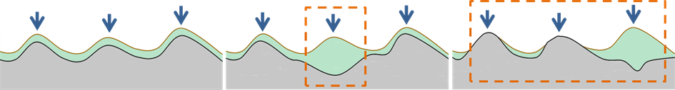

Figure 2: Pictorial explanations of the working definitions. **Left:** A blanket bog landscape solely consisting of blanket bogs, i.e. ombrogenous peatlands in which the peatland’s surface relief completely follows the underlying mineral soil and the peatland water divides reflect the underlying mineral soil water divides. **Centre:** A blanket bog landscape dominated by blanket bogs but with a raised bog included. The raised bog water divide does not reflect the underlying mineral soil water divide. **Right:** Although the surface relief is again the same as in the other pictures, this landscape is not a blanket bog landscape. No blanket bogs are present because no mineral hill top is covered by (at least 30 cm of) peat and the peatland water divide does not reflect the water divide in the underlying mineral soil.

1. 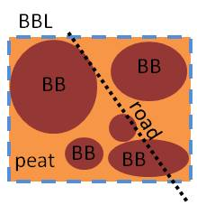2. 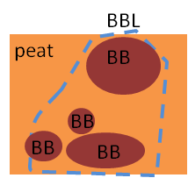3. 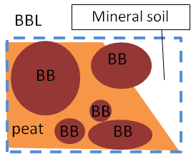4. 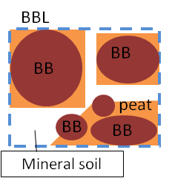

Figure 3: Examples of blanket bog landscape (BBL) configurations with inclusion of various non blanket bog (BB) elements. 1. A BBL with BBs and other peatlands. BBs are dominant, the BBL solely consists of peatland and includes all contiguous peatland. Human lineaments do not affect the delineation of a BBL. 2. A BBL with BBs and other peatlands. Within the deliniated BBL, BBs are dominant. The BBL solely consists of peatland but excludes part of the contiguous peatland to satisfy the 50% BB criterion. 3. A BBL with BBs, other peatlands and mineral soil. The other peatland and mineral soil area can be included in the BBL in order to arrive at a landscape ecologically coherent area (e.g. catchment area), as long as BBs occupy at least 50% of the total BBL area. 4. A BBL with BBs, other peatlands and mineral soil. BBs separated by mineral soil can be included in one BBL in order to arrive at a landscape ecologically coherent area (e.g. catchment area), as long as BBs occupy at least 50% of the total BBL area.

## 3.3 Blanket bog landscapes

Major potential blanket bog occurrences outside the tropics and high mountains were found for Ireland, Great Britain, Canada, Argentina, Chile, Tasmania, New Zealand and the Subantarctic Islands (Figure 4). No major blanket bog occurrences could be confirmed for Kamchatka, whereas blanket bog landscapes in other parts of the world were too small to be compared with the Flow Country.

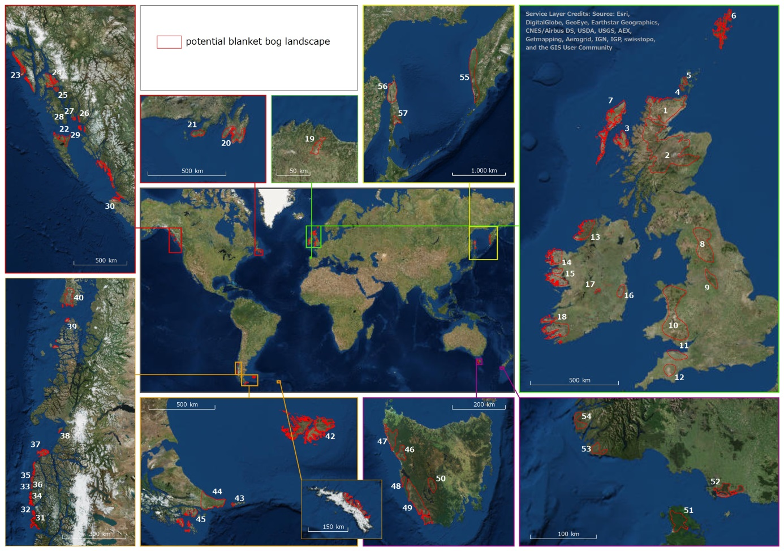

|  |  |  |  |  |  |  |  |
| --- | --- | --- | --- | --- | --- | --- | --- |
| 1 | Flow Country | 16 | Wicklow | 31 | Isla Mornington | 46 | W Tasmania |
| 2 | Central Highlands | 17 | Mountmellick | 32 | Isla Stosch | 47 | NW Tasmania |
| 3 | Skye | 18 | Kerry | 33 | Isla Duque de York | 48 | Birthday Bay |
| 4 | Hoy | 19 | Serra do Xistral | 34 | Isla Wellington | 49 | SW Tasmania |
| 5 | Orkney Mainland | 20 | Avalon Peninsula | 35 | Isla Wellington | 50 | C Tasmania |
| 6 | Shetland Islands | 21 | Burin Peninsula | 36 | Isla Wellington | 51 | Stewart Island |
| 7 | Outer Hebrides | 22 | Graham Island | 37 | Isla Byron | 52 | S New Zealand |
| 8 | Pennines | 23 | Chichagof Island | 38 | Isla Javier | 53 | Kiwi Lake |
| 9 | Peak District | 24 | Kupreanof Island | 39 | Bahia Low | 54 | Lake Rimmer |
| 10 | Wales | 25 | Zarembo Island | 40 | Isla Gr. de Chiloé | 55 | West Kamchatka |
| 11 | Exmoor | 26 | Humpback | 41 | Sandwich Island | 56 | North Sakhalin |
| 12 | Dartmoor | 27 | Duke Island | 42 | Falklands/Malvinas | 57 | South Sakhalin |
| 13 | Donegal | 28 | Hotspur Island | 43 | Isla des los Estados |  |  |
| 14 | Mayo | 29 | Dundas Island | 44 | Peninsula Mitre |  |  |
| 15 | Connemara | 30 | SW Canada | 45 | Isla Navarino |  |  |

Figure 4: Location of major potential blanket bog occurrences worldwide outside the tropics and high mountains.

In **Europe**, blanket bogs are widespread over the **British Isles** (e.g. Osvald 1949, Gore 1968, Moore 1972, Merryfield & Moore 1974, Hammond 1981, Chambers 1982, Doyle 1983, Moore et al. 1984, Tallis 1991, 1998, Stoneman 1997, Bragg & Tallis 2001, Connolly et al. 2007, Figure 4: 1-18).

A large number of individual blanket bogs are mentioned for the coastal regions of south and middle **Norway** and the Lofoten Islands (Hafsten & Solem 1976, Moen & Olsen 1983, Moen 1972, 1983, 1985, Moen et al. 2011, Solem 1989, 1991, Damman 1995). Blanket bog landscapes are, however, small (not depicted in Figure 4).

Blanket bogs are mentioned for western **Iceland** (Johannesson 1960, Goodwillie 1980, Tallis 1995, cf. Glawion 1985). The organic soils of Iceland are, however, rather small in extent and largely drained (Barthelmes et al. 2015) (not depicted in Figure 4).

The **Faroe Islands** also have blanket bogs (Lawson et al. 2007), but a peatland area of merely 17 km2 (Edwards & Fosaa 2016) (not depicted in Figure 4).

Blanket bogs are furthermore mentioned for the Serra do Xistral (Barreiras do Lago), Pico Xistral, Montes dos Cabaleiros, Montas del Pardo, and Alto de Zalama (**Spain**, Garcia-Rodeja et al. 2015, Heras-Pérez et al. 2016, Figure 4: 19).

The reported blanket bogs of the ‘Black Forest‘ (**Germany**, Sengbusch 2011), Bretagne and the Central Massif (**France**, Durfort 2007, Cubizolle et al. 2012), the Giant Mountains (**Czech Republic**, Osvald 1925), Terceira Island (**Azores**, Mendes 1998, Mendes & Dias 2016), the Carpathian Mountains (**Ukraine**, Felbaba-Klushina 2010) and other such references were not further evaluated because of the small areal extent (not depicted in Figure 4).

Along the east coast of **Canada**, blanket bogs are mentioned for Newfoundland, Labrador), New Brunswick and Nova Scotia (Zoltai & Pollett 1983, Tallis 1995).

In spite of its cool maritime climate and wide variety of extensive wetlands and peatlands (Jones et al. 2010) including raised bogs (Foster 1984, Foster & King 1984, Glaser & Foster 1984), our analyses did not reveal occurrences of blanket bog in **Labrador**. For **Nova Scotia**, stratigraphic profiles (Auer 1930, Anderson & Broughm 1988, cf. Damman 1979) support the existence of blanket bogs, chiefly along the Atlantic coast from Halifax to Sydney and Cape Breton Highlands (Anderson & Broughm 1988, not depicted in Figure 4). The most extensive blanket bog landscapes in Eastern Canada are found in the southernmost part of **Newfoundland** (Avalon Peninsula and Burin Peninsula, Davis 1984, Wells & Hirvonen 1988, Price 1992a, b, Damman 1995, Graniero & Price 1999, Figure 4: 20-21) and in **New Brunswick** (Wells 1981, Pollett 1968, not depicted in Figure 4). The Avalon Peninsula lacks forest cover and has a vast peatland area with many pools on undulating ground. The New Brunswick area appeared in satellite and aerial imagery as highly degraded by peat-extraction and was therefore excluded from further analysis.

Along the **North American Pacific Coast**, blanket bogs are mentioned from the north end of Vancouver Island (Hebda 1983) northwards to Haida Gwaii/Queen Charlotte Islands and Prince Rupert (**Canada**) and adjacent Alaska (USA) (Figure 4: 22-30). The archipelago is predominantly covered by a rather dense forest on steep and rough mountainous terrain. This area receives the most precipitation in Canada and wetlands cover up to 75% of the terrain, but most are rather small due to constraining topography (Banner et al. 1988).

Soil maps show organic soils over the entire archipelago (Jones et al. 2010) and a large coherent area of peatland is identifiable on Graham Island, the northern island of Haida Gwaii, which is called ‘blanket bog’ by Quickfall (1984) (Figure 4: 22). The ‘slope bogs’ of this region occur on virtually all slope positions from level terrain to very steep (up to 70%) slopes, “hence resembling blanket bogs” (Banner et al. 1988). Flat and raised bogs cover extensive areas of the Queen Charlotte Lowland. Slope or blanket bogs are especially widespread on the windward Queen Charlotte Ranges, where the consistently cool, cloudy, humid, and wet conditions cause them in some areas to occur more or less continuous from sea level to alpine. The bogs form a “blanket mire complex”, with fens and swamps being far less extensive than bogs (Banner et al. 2014). The peat depth reflects the underlying topography and ranges from discontinuous accumulations less than 50 cm deep to continuous blankets over 2 metres deep (Stephens et al. 1970). The large variety in peat depth suggests that wet depressions in the underlying bedrock have acted as nuclei for peat accumulation from which the ‘bogs’ expanded and coalesced over the higher areas. The peat is extremely acid, the ash content generally low. ‘Ombrotrophic slope bogs’ with more than 1-2 m deep accumulations of *Sphagnum* peat are common on gently sloping and less exposed terrain than the shallow ‘minerotrophic slope bogs’ (Banner et al. 1988). The available profiles of such ‘sloping bogs’ (e.g. Banner et al. 1988 Figures 8-11, 8-12) do, however, not show the typical characteristics of blanket bog, i.e. a relief parallel peat layer and peat occurrences also on the water divides.

Blanket bogs are also mentioned for adjacent Southeast **Alaska** (Tallis 1995), where the sloping peatlands are similarly forested (Stephens et al. 1970, Harris et al. 1974, D’Amore & Lynn 2002). Also in Southern Alaska, open needleleaf forested peatlands occur that may cover fairly steep slopes (and watersheds) in areas with very high rainfall and low permeability (such as Glacier Bay, Prince William Sound and Kenai Fjords, Boggs et al. 2014).

In contrast the peatlands of the **Aleutian Islands** (cf. Shacklette & Rubin 1969, Shacklette et al. 1969, Savinetsky et al. 2014, Tallis 1995, not depicted in Figure 4) are non forested (Boggs et al. 2014) and may look very similar to the blanket bogs of Scotland (cf. <http://ubwp.buffalo.edu/ratislandsresearch/2015/01/21/peat-cores-on-kiska-island/bigelow-coring-6/>).

For **South America**, blanket bog occurrences are mentioned for the Magellanic Tundra (**Chile**, Pisano 1983), Tierra del Fuego (especially Peninsula Mitre, Grootjans et al. 2014, Iturraspe et al. 2012) and Isla de los Estados (**Argentina**), the **Falkland Islands/Malvinas** (Pisano 1983, Diaz & Valdes 2015), **South Georgia** (Tallis 1995) and **Gough Island** (Schwaar 1977).

The Magellanic Tundra (Figure 4: 31-40, 45) consists of a complex of small islands with peatlands and forest in a rough and steep landscape (Pisano 1983, Arroyo et al. 2005, Gardi et al. 2014). Because of its scattered single islands, the Magellanic Tundra cannot be characterized as a contiguous blanket bog landscape comparable in size and coherence with the Flow Country.

In Tierra del Fuego, peatlands generally dominate the valleys, and hillsides are covered by forest. Its eastern part, Peninsula Mitre (Figure 4: 44), however, is a vast open peatland area interspersed with mountainous mineral outcrops and forests. Extensive genuine blanket mires (including ‘cushion-plant blanket bog‘, Grootjans et al. 2014) occur in Peninsula Mitre (Iturraspe 2010, Grootjans et al. 2014, Díaz & Valdés 2015), which is covered for 45% with peatlands of which 65% has a slope > 3% (Iturraspe et al. 2012).

The Falkland Islands/Malvinas (Figure 4: 42) have no forest cover and very extensive peatlands. Darwin wrote in the 1830s: “The whole surface of the land is covered by a thick bed of peat soil or peat. […] The protection from wear & tear, thus afforded to the underlying rocks, must be more complete than perhaps in any other situation.” (Armstrong 1992). In his diary of a 4-day long cross-country ride in March 1834, Darwin noted: “nothing could be less interesting. The country is uniformly the same; an undulating moorland”. Similarly he wrote in 1834: “… there is no fire wood bigger than Heath & the whole country is more or less elastic peat bog.” (Armstrong 1992). Similar to the eastern part of Peninsula Mitre, an important vegetation component is *Astelia*, which forms a type of ‘blanket bog’ peculiar to the Southern Hemisphere. The peat consists of disjunct domes, which merge to form large areas of blanket peat, particularly in the wetter parts of the islands. However there is probably peat development occurring under most vegetation types in the Falklands (Fenton 2014).

In **Australasia**, blanket bogs are mentioned for Tasmania (Australia), Stewart Island, the far South of South Island (New Zealand) and for several islands in the Southern Pacific Ocean, e.g. Chatham Island and the Subantarctic Islands (McGlone 2002, Selkirk-Bell & McGlone 2005, Whinam et al. 2012). The smaller islands have not been further analysed.

The ‘buttongrass moorlands’ of **Tasmania** (Figure 4: 46-50) are often named blanket bogs (Pemberton et al. 2005, cf. Whinam et al. 2012) and indeed share many characteristics with them (widespread peat cover on slope, ridge and valley; acidic environment), but often have a more shallow peat layer (usually only 15-20 cm, Whinam et al. 2012) than the default 30 cm from the definition (Section 3.2). Also the practical distinction between ombrotrophic and minerotrophic is unclear, as the Precambrian quartzite in Tasmania is dramatically infertile (Whinam & Hope 2005). Tasmanian buttongrass moorlands cover about 1 million ha of undulating terrain in the western part of the State. They occur in regions with more than 1600 mm of annual rainfall, high humidity (typically > 80%) and low evaporation, but with relatively dry and mild summers. They are best developed on inert siliceous substrates and extend from close to sea level to > 700 m and from relatively flat ground to slopes of > 40°. The peat can be up to 4 m deep but mostly more shallow (Pemberton et al. 2005).

For **New Zealand**, blanket bog is mentioned for Stewart Island, Chatham Island and the southern part of South Island (Whinam et al. 2012, Figure 4: 51-54). These mire areas are small in comparison to the Flow Country.

For **Northeast Asia**, blanket bog landscapes have been reported from Kamchatka and Sakhalin (**Russia**), Hokkaido (**Japan**) and the Kuril Islands (Gore 1983, Tallis 1995, Botch & Masing 1983).

**Sakhalin** (Figure 4: 56-57) has a rather high peatland density (Olenin 1956/1957). Peat extraction is common, but in the eastern part of the island still some pristine peatlands exist. On aerial imagery the peatlands have a flat appearance with densely occurring pools. Minayeva (2015, pers. comm.) addressed them as "flat bogs rather than blanket bogs". Peat stratigraphic profiles of Vlastova (1960) also support classification as raised bog or slightly sloping mire/bog (not covering watersheds) rather than blanket bog.

A large area of mires (6 million ha) is found on **Kamchatka** (see maps in Olenin (1956/1957, Figure 4: 55). Botch (1995) considered the mires in West Kamchatka, where peatlands cover 80% (2.5 mln ha) of the landscape, “to be blanket bogs which are typical for England, Ireland, Norway and other suboceanic areas” and distinguished “two bog types on watersheds” (cf. Neustadt 1936). Furthermore she writes: “It must be noted that Kamchatka blanket bogs have many common features with west European ones. They cover hills, valleys, slopes, terraces. The vegetation consists of both common species (i.e. both occurring in oceanic Norway and Kamchatka) and eastern Siberian ones. […] High paludification of western Kamchatka is caused by a lot of underground water moving from the mountains to the sea. This appears in bogs in forms of streams, pools, small craters and other forms, which are typical of the Atlantic Sea area, too.”

However, Botch & Masing (1983) show raised bog profiles as typical peat profiles for west Kamchatka, whereas they also state: “The mire complexes of western Kamchatka are separated into a special regional type of raised bogs”. Also Neustadt (1936) describes the relief of the peatlands of the west coast as being convex, sometimes more, sometimes less. The often very gently sloping landscape relief (e.g. 0.3 % over a length of almost 50 km going from west to east) does not provide convincing evidence for the existence of blanket bog. Botch (1995) may - while referring to ‘blanket bogs’ - have intended to highlight the extensive ‘blanket’ character of the mire landscape, without acknowledging the special characteristics of blanket bogs (see Section 3.2).

On the **Kuril Islands** only small mires are found (Botch & Masing 1983). These occur mainly on coastal sites and are mostly degraded by peat extraction or agriculture (not depicted in Figure 4).

Gore (1983) and Tallis (1995) describe blanket bogs for some mountains in Northern **Japan** (not depicted in Figure 4). Climatic conditions suitable for the development of ombrogenous peatlands occur in Japan only on Hokkaido and in the mountains of Honshu (Damman 1988). The peatlands of Hokkaido are largely degraded by intensive agriculture, but small areas of mire can be found in mountains and coastal areas (Hotes 2004, Kushiro International Wetland Centre 1996). Damman (1988) found that, in spite of their clearly raised surface, no Japanese bog has a genuine ‘ombrotrophic’ vegetation but rather a poor or extremely poor fen vegetation (cf. Sjörs 1950), which was attributed to enrichment by tephra. Damman did not find any blanket bogs. Also because of their small extent the mires of Japan have thus been excluded from further analysis.

## 3.4 Quality comparison

An overview of gross size and degradation of the blanket bog landscapes is given in Table 2 and Figures 5 and 6 (note that the blanket bog landscapes may contain substantial other landscape types, peatland types other than blanket bog, and degraded blanket bog, cf. Figure 3).

The largest potential blanket bog landscapes with the least degradation are West Kamchatka

55), North Sakhalin (56), Falklands/Malvinas (42) and South Sakhalin (57), of which only Falklands/Malvinas have confirmed blanket bogs. The next in row are Central Highland Scotland (2) and Wales (10), which both have a very substantial degraded area. Peninsula Mitre (44) is similar in quality as the Falklands/Malvinas but smaller in size. With respect to high quality area, Avalon Peninsula (20) and the Flow Country (1) score equal, but the latter is larger in gross size. All other areas are smaller in gross size and high quality area than the Flow Country.

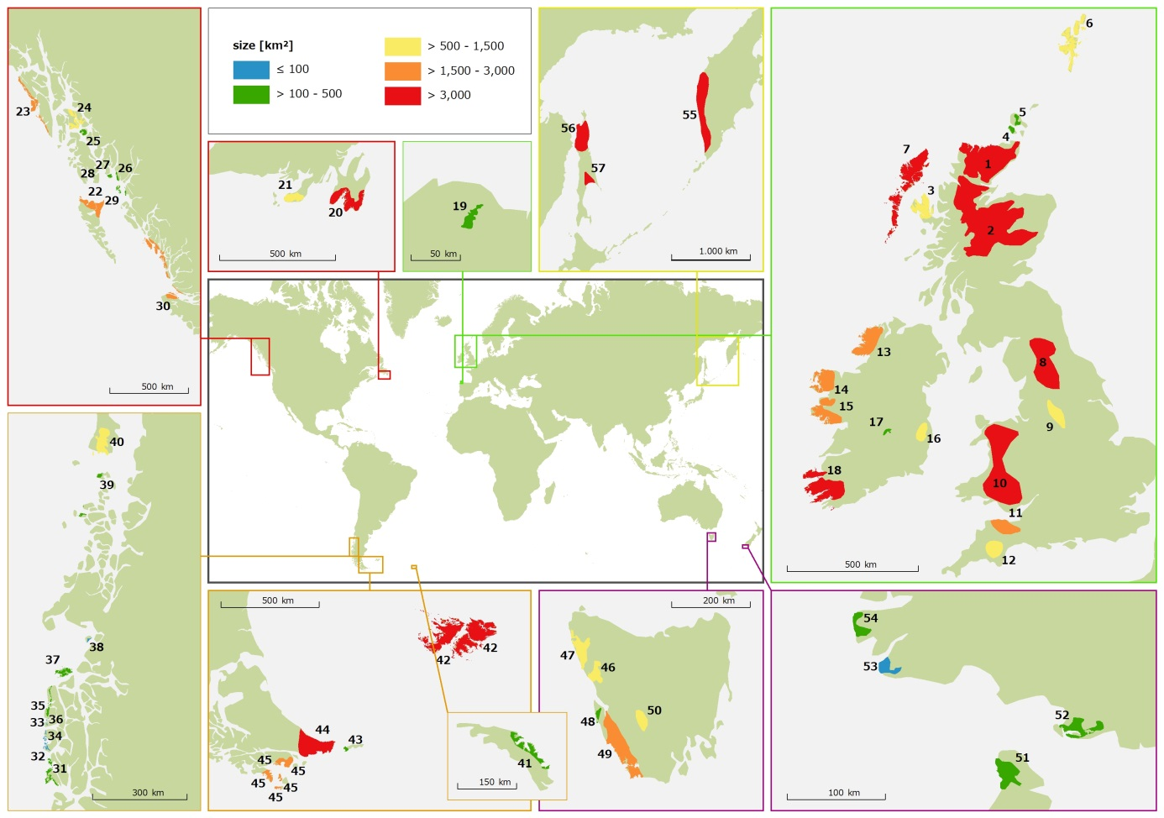

Figure 5: Gross size of the potential blanket bog landscapes (for names of sites, see Figure 4).

Table 2: Gross size and degradation of the potential blanket bog landscapes

|  |  |  |  |  |  |
| --- | --- | --- | --- | --- | --- |
| **Nr** | **Name** | **Country** | **Gross area [km²]** | **Degraded area %** | **Undegraded area [km²]** |
| 55 | West Kamchatka | RUS | 33639 | 0 | 33639 |
| 56 | North Sakhalin | RUS | 20121 | 2 | 19719 |
| 42 | Falklands/Malvinas | UK | 12376 | 2 | 12129 |
| 57 | South Sakhalin | RUS | 5484 | 2 | 5375 |
| 2 | Central Scotland | UK | 13430 | 60 | 5372 |
| 10 | Wales | UK | 9922 | 50 | 4961 |
| 44 | Peninsula Mitre | ARG | 4609 | 0 | 4609 |
| 20 | Avalon Peninsula | CAN | 3338 | 5 | 3171 |
| 1 | Flow Country | UK | 5682 | 45 | 3125 |
| 7 | Outer Hebrides | UK | 3222 | 10 | 2899 |
| 30 | South West Canada | CAN | 2905 | 2 | 2847 |
| 49 | South West Tasmania | AUS | 2796 | 3 | 2712 |
| 22 | Graham Island | CAN | 2426 | 0 | 2426 |
| 45 | Isla Navarino | CHI | 1616 | 0 | 1616 |
| 23 | Chichagof Island | US | 1569 | 0 | 1569 |
| 24 | Kupreanof Island | US | 1469 | 0 | 1469 |
| 40 | Isla Grande de Chiloé | CHI | 1396 | 0 | 1396 |
| 6 | Shetland Islands | UK | 1480 | 10 | 1332 |
| 47 | North West Tasmania | AUS | 1145 | 0 | 1145 |
| 21 | Burin Peninsula | CAN | 1168 | 5 | 1110 |
| 12 | Dartmoor | UK | 1394 | 30 | 976 |
| 15 | Connemara Peninsula | IRE | 2134 | 60 | 854 |
| 3 | Skye | UK | 1195 | 30 | 837 |
| 18 | Kerry | IRE | 4103 | 80 | 821 |
| 14 | Mayo Peninsula | IRE | 1852 | 60 | 741 |
| 8 | Pennines | UK | 4925 | 85 | 739 |
| 13 | Donegal | IRE | 2277 | 70 | 683 |
| 46 | West Tasmania | AUS | 667 | 0 | 667 |
| 50 | Central Tasmania | AUS | 605 | 0 | 605 |
| 41 | South Georgia | UK | 493 | 0 | 493 |
| 37 | Isla Byron | CHI | 331 | 0 | 331 |
| 25 | Zarembo Island | US | 312 | 0 | 312 |
| 31 | Isla Mornington | CHI | 268 | 0 | 268 |
| 29 | Dundas Island | US | 252 | 0 | 252 |
| 51 | Stewart Island | NZ | 224 | 0 | 224 |
| 39 | Bahia Low | CHI | 170 | 0 | 170 |
| 11 | Exmoor | UK | 1676 | 90 | 168 |
| 16 | Wicklow | IRE | 810 | 80 | 162 |
| 27 | Duke Island | US | 161 | 0 | 161 |
| 26 | Humpback | US | 158 | 0 | 158 |
| 36 | Isla Wellington | CHI | 145 | 0 | 145 |
| 48 | Birthday Bay | AUS | 139 | 0 | 139 |
| 9 | Peak District | UK | 1289 | 90 | 129 |
| 52 | South New Zealand | NZ | 179 | 30 | 125 |
| 43 | Isla des los Estados | ARG | 121 | 0 | 121 |
| 54 | Lake Rimmer | NZ | 109 | 0 | 109 |
| 4 | Hoy | UK | 116 | 10 | 104 |
| 53 | Kiwi Lake | NZ | 98 | 0 | 98 |
| 32 | Isla Stosch | CHI | 88 | 0 | 88 |
| 19 | Serra do Xistral | SPA | 108 | 20 | 87 |
| 5 | Mainland Orkney | UK | 159 | 50 | 80 |
| 38 | Isla Javier | CHI | 34 | 0 | 34 |
| 17 | Mountmellick | IRE | 140 | 80 | 28 |
| 33 | Isla Duque de York | CHI | 17 | 0 | 17 |
| 34 | Isla Wellington | CHI | 7 | 0 | 7 |
| 35 | Isla Wellington | CHI | 6 | 0 | 6 |
| 28 | Hotspur Island | CAN | 3 | 0 | 3 |

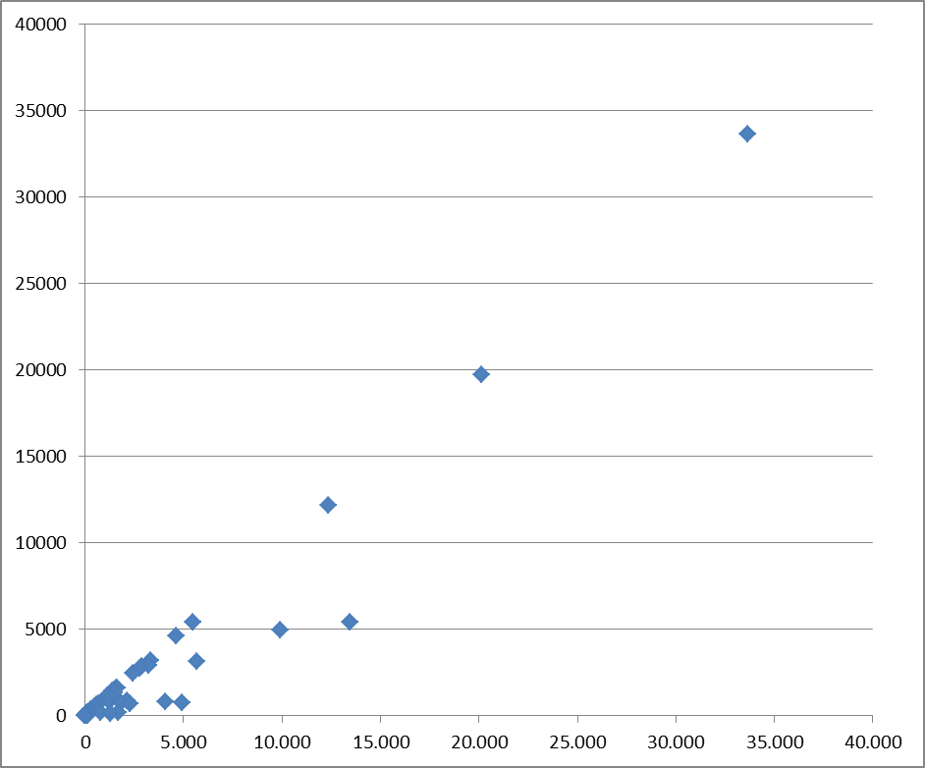

Avalon

P. Mitre

Central Scotland

Wales

S Sakhalin

Falklands/Malvinas

North Sakhalin

Flow Country

West Kamchatka

Figure 6: Size/quality relation of the identified potential blanket bog areas. X-axis: gross size (km2), Y-axis: size of undegraded area (km2).

# 4. Discussion

## 

## 4.1 Definitions, identification and delineation

The term ‘blanket bog’ (or blanket mire) is used with various meanings (Section 3.2), whereas various authors do not specify their concept while discussing blanket bogs.

Two elements of the ‘blanket bog’ definition may be a source of confusion. The ‘blanket’ might be interpreted to mean a large extent. Large extents of mires always give the impression of covering the landscape as a blanket independent of the subsoil. This is due to their extremely high (85-95%) water content so that the surface of living mires cannot make major ‘relief jumps’, because water cannot form static relief differences. The basic criterion of a blanket bog is, however, also that the peatland must – at least locally - cover a (substantial) slope. This criterion requires a very large and evenly distributed water supply (cf. spring mires) and/or severely restricted evapotranspiration losses (Joosten & Clarke 2002).

The term ‘bog’ means that the source of water may only be atmospheric. Atmospheric precipitation is always intermittent so that the condition of continuous water supply is not fulfilled and restriction of water losses is paramount. Next to restricted evapotranspiration (which is virtually impossible to stop completely) a bog with a substantial slope *must* have a low hydraulic conductivity of the peat to prevent the water level from falling and inducing oxidation, which would jeopardize the persistence of the peatland. As a purely ombrotrophic ecosystem, a blanket bog normally has an oligotrophic acid vegetation. However, as discharge of acid oligotrophic groundwater may also give rise to oligotrophic acid mire vegetation, the presence of a ‘blanket bog’ can only be convincingly confirmed when an oligotrophic acid peatland also covers the highest points in the landscape: the water divides.

A landscape rich in relief will always have places where groundwater recharge and places where groundwater discharge are taking place. Therefore, an extensive blanket bog landscape will never consist of only bogs but will also include groundwater fed fens. This phenomenon has promoted the use of the terms/concepts ‘blanket mire’ (e.g. Moore *et al*. 1984, Solem 1989) and ‘blanket mire landscape’ (e.g. Tallis 1998, Lindsay *et al*. 2014). We recommend avoiding these terms and using only the term ‘blanket bog landscape’ to stress that blanket *bogs* are and *must* be a distinct part of the landscape and that the landscape does not solely consists of (extensive) sloping fens or flat (non-sloping) bogs.

As peat stratigraphical profiles are generally not available, the unambiguous identification of blanket bog requires information on the surface relief of both the peatland itself and its mineral subsoil. Also for identification of landscape slopes and watersheds, elevation data are required. These may, dependent on resolution, provide different perspectives, as became apparent in the example of Kamchatka, which appeared rather flat in Google physical imagery whereas higher resolution STRM data showed a more strongly moving relief.

Further identification of blanket bog and bog degradation was performed by remote analysis of surface colours and patterns and their similarity to those of the Flow Country. In this way heavily forested areas were implicitly excluded from possible blanket bog identification. This was considered acceptable, because in climates that support blanket bog formation, mires are generally not heavily forested because of acidity, lack of nutrients and prevailing high water levels. Furthermore heavily forested blanket bogs would, should they exist, be so different from the Flow Country that they would not compete for ‘uniqueness’.

Depending on quality, BING or Google imagery was chosen, of which the former seemed often to be more up to date. Older imagery has generally lower resolution and poorer contrast, brightness and colour authenticity. Seasonal variation in recording date can hamper comparability and consistent interpretation, and landscapes in different climatic and floristic regions and with different land use may differ substantially in remotely sensed appearance, resulting in the same features being ascribed to different categories and vice versa.

The methods applied are proxy studies with which *potential* blanket bog areas were identified. Confirmation of blanket bog occurrences requires unambiguous descriptions in the literature (including peat stratigraphical profiles) or ground truthing. Helpful maps and information in this respect were provided for Tierra del Fuego, New Zealand, Great Britain, Norway and Spain. Blanket bog is a generally undervalued resource in most parts of the world where other mire types prevail and blanket bogs only take up minor parts. As our aim was not to identify all blanket bog areas of the world (which would be an interesting challenge!), but to concentrate on the major occurrences, this lack of knowledge will not have influenced the final results substantially.

When the presence of blanket bog is confirmed by compliance to the criteria ‘covering a substantial slope’ and ‘covering a watershed’, the question arises how far a blanket bog massif (i.e. not a blanket bog *landscape*) extends beyond the slope and watershed. Does contiguous flat ombrotrophic mire also belong to the ‘blanket bog’ or should that be assigned to another mire type. A ‘sensu stricto’ position with respect to this criterion would strongly decrease the incidence of ‘blanket bog’ and thus strongly influence the delineation of blanket bog *landscapes*. We rather used the broad approach by including all oligotrophic acid mires contiguous with a confirmed (slope + watershed) blanket bog in our blanket bog, ‘sensu lato’ concept.

*How much* blanket bog a blanket bog landscape must hold is a critical variable when landscape size is considered an important criterion. In fact a blanket bog landscape should derive its ‘character’ from the blanket bogs present in that landscape. Instead of such a qualitative and subjective criterion (which would indeed better fit the individuality of the concrete landscapes), we have set a relative, pseudo-quantitative threshold to enable ‘objective’ comparison among sites: ‘A BBL may include areas that are not blanket bog, but these areas collectively cover less area than blanket bog’ (Section 3.2). In our reconnaissance we applied the threshold criterion therefore rather loosely and drew the boundaries pragmatically along natural borders, including coasts, mountains and river valleys and focused on unforested natural areas. We do not expect that this approach influences the robustness of the conclusions.

## 4.2 Valuation

To assess the quality of blanket bog landscapes, we used ‘size’ and ‘degree of degradation’. These two criteria constitute only two of the wide variety of quality criteria for peatland valuation (cf. Cross 1990, Moen 1995, Joosten 1996, 2001). Size is both a direct (as larger sites are rarer) and an indirect indicator of conservation value (as larger sites may contain more - unknown and rare - elements), whereas larger size also reduces proportional management costs through efficiency of scale and reduction of edge effects (Joosten 2001).

The criterion ‘degree of degradation’ is expressed as the percentage of area that is/has been subject to peat extraction, forestry, agriculture, drainage and peat erosion, i.e. factors that lessen the naturalness value of the site (cf. World *Natural* Heritage). The same factors and associated patterns may, however, increase the value of the site as a *cultural* monument, i.e. as an expression of former and present human activities (cf. Joosten 1987). Furthermore the variable ‘erosion’ is not always an indicator of anthropogenic disturbance and degradation, because blanket bog erosion may be not only and/or not completely anthropogenic (Tallis et al. 1997, Evans & Warburton 2010).

# 5. Conclusion

The five ‘potential blanket bog landscapes’ worldwide with a larger gross size than the Flow Country include

* two areas for which no blanket bog occurrence was confirmed (Kamchatka, North Sakhalin in NE Asia),
* two areas, which are strongly degraded (Central Highland Scotland, Wales), and
* one site (Falklands/Malvinas) in the extreme southern hemisphere with a completely different blanket peat forming flora (Kleinebecker *et al*. 2008, Grootjans et al. 2014).

When only the area of non-degraded landscape is considered, additionally only South Sakhalin (no blanket bog confirmed) and Peninsula Mitre (similar to the Falklands/Malvinas but smaller in size) score higher than the Flow Country. Avalon Peninsula (Newfoundland) and the Flow Country score equal in non-degraded landscape size, but the Flow Country is larger in gross size. All other areas are smaller in both gross size and high quality area than the Flow Country.

The Flow Country can thus justly be called a ‘*primus inter pares*’ of the blanket bog landscapes worldwide.

# Acknowledgements

Andrew Coupar, Richard Lindsay, Clifton Bain, Roxane Andersen, Sue White, Eduardo Garcia-Rodeja, Asbjörn Moen, Rodolfo Iturraspe, Jennie Whinam, Bev Clarkson, Tatjana Minaeva, and those colleagues who assisted them, are acknowledged for their conceptual and practical contributions.

# References

Anderson, J. (1794) A practical treatise on peat moss: considered as in its natural state fitted for affording fuel, or as susceptible of being converted into mold capable of yielding abundant crops of useful produce; with full directions for converting it from the state of peat into that of mold, and afterwards cultivating it as a soil. xxvi +150 p. London: T. Chapman.

Anderson, A.R. & Broughm, W.A. (1988) Evaluation of Nova Scotia’s peatland resources. 109 p. Halifax: Nova Scotia Department of Mines and Energy Bulletin 6.

Armstrong, P. (1992) Darwin’s desolate islands: a naturalist in the Falklands, 1833 and 1834. 147 p. Chippenham: Picton Publishing.

Arroyo, M.T., Plicoff, P., Mihoc, M. & Arroyo-Kalin, M. (2005) The Magellanic moorland. In: The World’s largest wetlands (ed. by H. Fraser & P.Keddy) pp. 424-445. New York: Cambridge University Press.

Auer, V. (1930) Peat bogs in Southeastern Canada. Canada- Department of Mines. Geological Survey. Memoir 162. Ottowa: Printer to the King's most excellent majesty.

Banner, A., Hebda, R.J., Oswald, E.T., Pojar, J & Trowbridge, R. (1988). Wetlands of pacific Canada. In: Wetlands of Canada (ed. by National Wetlands Working Group) Ecological Land Classification Series No. 24, pp. 305-346. Quebec: Polyscience Publications.

Banner, A., MacKenzie, W.H., Pojar, J., MacKinnon, A., Saunders, S.C. & Klassen, H. (2014) A field guide to ecosystem classification and identification for Haida Gwaii. 258 p. Prov. B.C., Victoria, B.C. Land Management Handbook 68, Downloadable under<https://www.for.gov.bc.ca/hfd/pubs/Docs/Lmh/Lmh68.htm>

Barthelmes, A., Couwenberg, J., Risager, M., Tegetmeyer, C. & Joosten, H. (2015) Peatlands and climate in a Ramsar context: A Nordic-Baltic Perspective. TemaNord 2015: 544. Nordic Council of Ministers, 244 p.

Boggs, K., Boucher, T. V. & Kuo, T. (2014) Vegetation map and classification: Southern Alaska and Aleutian Islands. Alaska Natural Heritage Program. 74 p. Anchorage: University of Alaska <http://aknhp.uaa.alaska.edu/wp-content/uploads/2012/12/Vegetation-Map-and-Classification-Southern-Alaska-and-Aleutian-Islands.pdf>

Botch, M. & Masing, V. (1983) Mire ecosystems in the U.S.S.R. In: Mires: swamp, bog, fen and moor. Ecosystems of the world 4B (ed. by A.J.P. Gore), pp. 95-152. Amsterdam: Elsevier.

Botch, M (1995) Mires of Kamchatka Peninsula. In: Consortium Masingii - A Festschrift for Viktor Masing (ed. by K. Aaviksoo, K. Kull, J. Paal & H. Trass) pp. 37- 42. Tartu: Tartu University.

Bragg, O.M. & Tallis, J.H. (2001) The sensitivity of peat-covered upland landscapes. Catena 42: 345–360.

Chambers, F.M. (1982) Two radiocarbon-dated pollen diagrams from high-altitude blanket peats in South Wales. Journal of Ecology 70: 445-459.

Conaghan, J., Douglas, C., Grogan, H., O’ Sullivan, A., Kelly, L., Garvey, L., Van Doorslaer, L., Scally, L., Dunnells, D., Wyse Jackson, M., Goodwillie, R. & Mooney, E. (2000) Distribution, ecology and conservation of blanket bog in Ireland. A synthesis of the reports of the NPWS blanket bog surveys of 1987, ’89, 90 and ’91. National Parks and Wildlife Service, Dúchas, The Heritage Service, Dublin. 137 p.

Connolly, J., Holden, N. M. & Ward, S. M. (2007) Mapping peatlands in Ireland using a rule-based methodology and digital data. Soil Science Society of America Journal 71: 492-499.

Cross, J.R. (1990) Survey and selection of peatland sites for conservation in the Republic of Ireland. In: Ecology and conservation of Irish peatlands (ed. by G.J. Doyle) pp. 175-188. Dublin: Royal Irish Academy.

Cubizolle, H., Fassion, F., Argant, J., Latour-Argant, C., Galet, P., & Oberlin, C. (2012) Mire initiation, climatic change and agricultural expansion over the course of the Late-Holocene in the Massif Central mountain range (France): Causal links and implications for mire conservation. Quaternary international 251: 77-96.

Damman, A.W.H. (1979) Geographic patterns in peatland development in eastern North America. In: Classification of peat and peatlands (ed. by E. Kivinen, L. Heikurainen & P. Pakarinen) pp. 42-58. Helsinki: International Peat Society.

Damman, A.W.H. (1988) Japanese raised bogs: their special position within the Holarctic with respect to vegetation, nutrient status and development. Veröff. Geobot. Inst. ETH, Stiftung Rubel, Zürich 98: 330-353.

Damman, A.W.H. (1995) Boreal peatlands in Norway and eastern North America: a comparison. In: Regional variation and conservation of mire ecosystems (ed. by A. Moen). Gunneria 70: 43-65.

D’Amore, D. V. & Lynn, W. C. (2002) Classification of forested histosols in Southeast Alaska. Soil Science Society of America Journal 66: 554–562.

Davis, A.M. (1984) Ombrotrophic peatlands in Newfoundland, Canada: their origins, development and trans-Atlantic affinities. Chemical Geology 44: 287–309.

Díaz, E.D. & Valdés, D.V. (eds.) (2015) Funciones y servicios ecosistémicos de las turberas en magallanes. Colección de libros INIA No 33. 334pp. Punta Arenas: Instituto de Investigaciones Agropecuarias. Centro Regional de Investigación Kampenaike.

Doyle, G.J. (1983) Conserving Bogland. In: Promise and performance: Irish environmental policies analysed (ed. by J. Blackwell & F. Convery) pp. 191-202. University College Dublin: Resource and Environmental Policy Centre.

Doyle, G.J. (ed.) (1990b) Ecology and conservation of Irish peatlands. 221 p. Dublin: Royal Irish Academy.

Davies, S.M. (2013) Future world heritage nominations: Assessment of technical evaluations by the expert

group: Flow Country. Unpublished.

Durfort, J. (ed.) (2007) Les tourbières de Bretagne. [The peatlands of Brittany] 176 p. Mèze: Biotope Éditions. (in French)

Edwards, K. J. & Fosaa, A. M. (2016) Faroe Islands. In: Mires and peatlands in Europe – Status, distribution and conservation (ed. by H. Joosten, F. Tanneberger & A. Moen). Stuttgart, Schweizerbart.

Evans, M. & Warburton J. (2010) Geomorphology of upland peat - erosion, form and landscape change. 262 p. Malden: Blackwell.

Felbaba-Klushina, L.M. (2010) Рослинний покрив боліт і водойм верхів"я басейну р. Тиса (Українські Карпати) та флювіальна концепція його охорони. [Plant cover of mires and waterbodies in the upper river Tisa basin (Ukrainian Carpathians)...] Ushgorod: Poligrafzentr, 129 p.

Fenton, J. (2014) Observations on Falkland Islands peat including long-term dynamics. 12 p. <http://www.james-hc-fenton.eu/Essays/FI%20peat%20dynamics%20-%20J%20Fenton%20-%205%20Sept%202014.pdf>

Forster, D.R. (1984) The dynamics of Sphagnum in forest and peatland communities in Southeastern Labrador, Canada. Arctic 37: 133-140.

Forster, D.R. & King, G.A. (1984) Landscape features, vegetation, and the developmental history of a patterned fen in southeastern Labrador, Canada. Journal of Ecology 72: 115-143.

Garcia-Rodeja, E., Pontevedra Pombal, X. & Fraga Vila, I. (2015 unpubl.) filled-in blanket bog inventory sheets.

Gardi, C., Angelini, M., Barceló, S., Comerma, J., Cruz Gaistardo, C., Encina Rojas, A., Jones, A., Krasilnikov, P., Mendonça Santos Brefin, M.L., Montanarella, L., Muñiz Ugarte, O., Schad, P., Vara Rodriguez, M.I. & Vargas, R. (eds.) (2014) Atlas de Suelos de América Latina y el Caribe. 176 pp. Luxembourg: Oficina de Publicaciones de la Unión Europea.

Glawion, R. (1985). Die natürliche Vegetation Islands als Ausdruck des ökologischen Raumpotentials. Paderborn: Schöningh, 208 p.

Glaser, P. H. & Forster, D. R. (1984) The vascular flora of raised bogs in southeastern Labrador and its phytogeographic significance. Canadian Journal of Botany 62: 1361-1364.

Goodwillie, R. (1980) European Peatlands. Nature and Environment Series No. 19. 76 p. Strasbourg: Council of Europe.

Gore, A.J.P. (1968) Comparative ecological studies on peats at two different altitudes in Northern England. In: Second International Peat Congress. Leningrad USSR 1963, Transactions Volume 1. (ed. by R.A. Robertson) pp.139-149 Edinburgh: Her Majesty's Stationery Office.

Gore, A.J.P. (1983) Introduction. In: Ecosystems of the World 4A. Mires: Swamp, bog, fen and moor. General studies (ed. by A.J.P. Gore) pp. 1-34 Ecosystems of the World 4A. Amsterdam: Elsevier Scientific Publishing Company.

Graniero; P.A. & Price, J. S. (1999) The importance of topographic factors on the distribution of bog and heath in a Newfoundland blanket bog complex. Catena 36: 233–254.

Grootjans, A., Iturraspe, R., Fritz, C., Moen, A. & Joosten, H. (2014) Mires and mire types of Peninsula Mitre, Tierra del Fuego, Argentina. Mires and Peat 14, Article 01: 1–20.

Hafsten, U. & Solem, T. (1976) Age, origin, and palaeo-ecological evidence of blanket bogs in Nord-Trøndelag, Norway. Boreas 5: 119-141.

Hammond, R.F. (1981) The peatlands of Ireland: to accompany peatland map of Ireland, 1978. Soil Survey Bulletin No. 35. 58 p. Dublin: An Foras Talúntais.

Harris, A. S., Hutchison, 0. K., Meehan, W R., Swanston, D. N., Helmers, A. E., Hendee, J. C. & Collins, T. M. (1974) The forest ecosystem of Southeast Alaska. I. The setting. Forest Service Gen. Tech. Rep. PNW-12. 41 p. Portland, Oregon: Pacific Northwest Forest and Range Experiment Station.

Hebda, R.J. (1983) Late-glacial and postglacial vegetation history at Bear Cove Bog, northeast Vancouver Island, British Columbia. Canadian Journal of Botany 61: 3172-3192.

Heras Pérez, P., Infante Sánchez, M., Pontevedra-Pombal, X & Nóvoa-Muñoz, J. C. (2016) Spain. In: Mires and peatlands in Europe – Status, distribution and conservation (ed. by H. Joosten, F. Tanneberger & A. Moen). Stuttgart, Schweizerbart.

Hotes, S. (2004) Kiritappu Mire in eastern Hokkaido, Japan – A review of its development, hydrology and vegetation. International Peat Journal 12: 75-98.

Iturraspe, R. (2010) Las turberas de Tierra del Fuego y el cambio climático global. 32 p. Buenos Aires : Fundación para la Conservación y el Uso Sustentable de los Humedales.

Iturraspe, R., Urciuolo, A. & Iturraspe, R. (2012). Spatial analysis and description of eastern peatlands of Tierra del Fuego, Argentina. In: Mires from Pole to Pole (ed. By T. Lindholm & R. Heikkilä). Helsinski: The Finnish Environment 38: 385-399.

Johannesson, B. (1960). The soils of Iceland- with a generalized map. Department of Agriculture, Reports Series B, No. 13. 140 pp.

Jones, A., Stolbovay, V., Tarnocai, C., Broll, G., Spaargaren, O. & Montanarella, L. (2010) Soil atlas of the Northern Circumpolar Region. Luxembourg: European Commission, Publ. Off. of the European Union, 144 p.

Joosten, H. (1987) Lange armen, grote neusgaten: De Ospelse Peel als cultuurreservaat. [Long arms, large nostrils: the Opselse Peel bog as a culture reserve] In: Nederweerts verleden. De kerk in het midden (ed. by A. Bruekers) pp. 131–141. Nederweert: Stichting Geschiedschrijving Nederweert.

Joosten, H. (1996) A world of mires: criteria for identifying mires of global conservation significance. In: Peatlands use - present, past and future (ed. by G.W. Lüttig) pp. 18-25 Stuttgart: Schweizerbart.

Joosten, H. (2001) Identifying peatlands of international biodiversity importance. http://www.imcg.net/media/download_gallery/paper/joosten_2001.pdf

Joosten, H. & Clarke, D. (2002) Wise use of mires and peatlands: Background and principles including a framework for decision-making. 304 p. Saarijärvi: International Mire Conservation Group and International Peat Society.

Joosten, H., Kopp, D. & Succow, M. (2001) Naturraumkunde und Landschaftsökologie von Mooren [Macrocore studies and landscape ecology of peatlands]. In: Landschaftsökologische Moorkunde, 2. Auflage [Landscape ecology of mires, 2nd ed.] (ed. by M. Succow & H. Joosten), pp. 3-7. Stuttgart: Schweizerbart. (in German)

Joosten, H., Moen, A., Couwenberg, J. & Tanneberger, F. (2016) Mire diversity in Europe: mire and peatland types. In: Mires and peatlands in Europe – Status, distribution and conservation (ed. by H. Joosten, F. Tanneberger & A. Moen). Stuttgart, Schweizerbart.

Kleinebecker, T., Vogel, A. & Hölzel, N. (2008) DIe Vegetation ombrotropher Moore Südpatagoniens [The vegetation of ombrotrophic mires in South-Patagonia]. Abhandlungen aus dem Westfälischen Museum für Naturkunde 70: 439 - 452. (in German)

Kushiro International Wetland Centre (1996) The 7th IMCG Field Symposium in Japan '96. Field Guide. (Contributors: Tachibana, H., Inoue, T., Hasegawa, S., Takahashi, H. & H. Shinsho).

Lawson, I.T., Church, M.J., Edwards, K.J., Cook, G.T. & Dugmore, A. J. (2007) Peat initiation in the Faroe Islands: climate change, pedogenesis or human impact? Transactions of the Royal Society of Edinburgh: Earth and Environmental Science 98: 15-28.

Lesquereux, L. (1844) Quelques recherches sur le marais tourbeaux en général. [Some studies on peatlands in general] 308 p. Neuchatel: Wolfarth. (in French)

Lindsay, R.A. (1995) Bogs: the ecology, classification and conservation of ombrotrophic mires. 120 p. Edinburgh: Scottish Natural Heritage.

Lindsay, R.A., Charman, D.J., Everingham, F., O’Reilly, R.M., Palmer, M.A., Rowell, T.A. & Stroud, D.A. (1988) The Flow Country. The peatlands of Caithness and Sutherland. 174 p. Peterborough: Joint Nature Conservation Committee.

Lindsay, R., Birnie, R., & Clough, J. (2014) Peat bog ecosystems: Key definitions. <http://www.iucn-uk-peatlandprogramme.org/resources/iucn-briefing-notes-peatlands?destination=node%2F277>

McGlone, M.S. (2002) The Late Quaternary peat, vegetation and climate history of the southern oceanic islands of New Zealand. Quaternary Science Reviews 21: 683–707.

Meade, R. (1998) Protection needs. In: Patterned mires and mire pools: origin and development; flora and fauna. Proceedings. (ed by V. Standen, J.H. Tallis and R. Meade). Mires Research Group, British Ecological Society, London.

Mendes, C. (1998) Contributo para a caracterização das turfeiras de Sphagnum da ilha Terceira [Contribution to the characterisation of Sphagnum mires of Terceira Island] Final course Dissertation. 168 p. Angra do Heroísmo: Department of Agricultural Sciences, Azores University. (in Portuguese)

Mendes, C. F.M. & Dias, E. M.F. (2016) Azores In: Mires and peatlands in Europe – Status, distribution and conservation (ed. by H. Joosten, F. Tanneberger & A. Moen). Stuttgart, Schweizerbart.

Merryfield, D.L. & Moore, P.D. (1974) Prehistoric human activity and blanket peat initiation on Exmoor. Nature 250: 439-441.

Moen, A. (1972) Klassifisering og verneverdi av myrer i Sør-Norge. Symposium om myr og torv. Myrlandskaper til allemnnyttige formål. Det Norske Myrselskap. Særtrykk av Meddelelser fra Det norske myrselskap. Nr. 4. Mariendals Boktrykkerie A/S, Gjøvik.

Moen, A. (1983) Myrundersøkelser i Sør-Trøndelag og Hedmark i forbindelse med den norske myrreservatplanen. Rapport botanisk serie 1983-4. Trondheim. xxx

Moen, A. (1985) Regionale studier og vern av myr i Sogn og Fjordane. Rapport botanisk serie 1985-1. Trondheim: Det Kgl. Norske Videnskabers Selskab, Museet.

Moen, A. (1995) The Norwegian national plan for mire nature reserves: methods, criteria and results. Gunneria 70: 159-176.

Moen, A & T.Ø. Olsen (1983): Myrundersøkelser i Sogn og Fjordane i forbindelse med den norske myrreservatplanen. Rapport botanisk serie 1983-5. Trondheim: det kgl. norske videnskabers selskab, museet.

Moen, A., Lyngstad, A. & Øien, D.-I. (2011): Scientific basis of an action plan for oceanic bogs in Norway /Kunnskapsstatus og innspill til faggrunnlag for oseanisk nedbørmyr som utvalgt naturtype. Rapport botanisk serie 2011-7. Trondheim: Norges teknisk-naturvitenskapelige universitet / Vitenskapsmuseet.

Moore, P.D. (1972) The initiation of peat formation and the development of peat deposits in mid-Wales. Proc. 4th Int. Peat Congr. Helsinki 1: 89–100.

Moore, P.D. & Bellamy, D.J. (1974) Peatlands. 221 p. London: Elek Science.

Moore, P.D., Merryfield, D.L. & Price, M.D.R. (1984) The vegetation and development of blanket mires. In: European mires (ed. by P.D. Moore), pp. 203-235. London: Academic Press.

Moss, C.E. (1913) Vegetation of the Peak District. Cambridge: Cambridge University Press.

Neustadt, M.I. (1936) Torfjanye bolota zapadnoi Kamchatki. [Peat mires of Kamchatka] Transactions of the Central Peat – Experimental Station of the People’s Commissariat for Agriculture of the RSFSR 1: 31- 45. (in Russian)

Olenin, A. S. (ed.) (1956/1957) Torfjanoj fond RSFSR. Sibir’ – Dal’nij Vostok [Peat fond of the RSFSR. Sibiria, Far East]. 149 + 297 p. Moscow. (in Russian)

Osvald, H. (1923) Die Vegetation des Hochmoores Komosse. [The vegetation of the raised bog Komosse] Svenska Växtsociologiska Sällskapets Handlingar 1: 1-436. (in German)

Osvald, H. (1925) Die Hochmoortypen Europas. [The raised bog types of Europe]. Festschrift Carl Schröter. Veröffentlichungen des Geobotanischen Institutes Rübel in Zürich 3: 707-723. (in German)

Osvald, H. (1949) Notes on the vegetation of British and Irish mosses. Acta Phytogeographica Suecica 26: 1–62.

Pemberton, M., Balmer, J., Driessen, M. & Richardson, A.M.M. (2005) Tasmanian blanket bogs – Geodiversity and biodiversity of these unique mires. In: Moore - von Sibirien bis Feuerland / Mires – from Siberia to Tierra del Fuego (ed. by G. M. Steiner). pp. 422-405. Linz: Biologiezentrum der Oberoesterreichischen Landesmuseen.

Pisano, E. (1983) The Magellanic tundra complex. In: Ecosystems of the world 4B. Mires: swamp, bog, fen and moor. Regional studies (ed. by A.J.P. Gore) pp. 295–329. Amsterdam: Elsevier Scientific Publishing Company.

Pollett, F. (1968) Peat resources of Newfoundland. Mineral resources report No. 2. Province of Newfoundland and Labrador, Department of Mines, Agriculture and Resources. Mines Branch. Miner. Resour. Rep. 2, St. John's, Nfld., 226 pp.

**Price, J.S. (1992a) Blanket bog in Newfoundland: Part 1. The occurrence and accumulation of fog-water deposits. Journal of Hydrology 135: 87–101.**

**Price, J.S. (1992b) Blanket bog in Newfoundland: Part 2. Hydrological processes. Journal of Hydrology 135: 103–119.**

**Quickfall, G. S. (1984) Paludification and climate on the Queen Charlotte Islands during the past 8000 years. B.Sc. Thesis Botany, 99 p. Vancouver: Simon Fraser University of British Columbia.**

Savinetsky, A. B., Khasanov, B. F., West, D. L., Kiseleva, N. K. & Krylovich, O. A. (2014) Nitrogen isotope composition of peat sSamples as a proxy for determining human colonization of islands. Arctic Anthropology 51: 77–85.

Schroevers, P.J. (red.) (1982) Landschapstaal: een stelsel van basisbegrippen voor de landschapsecologie. Reeks Landschapsstudies. Pudoc, Wageningen.

Schwaar, J. (1977) Humifizierungswechsel in terrainbedeckenden Mooren von Gough Island/Sudatlantik. [Change of humification in the blanket bogs of Gough Island, South Atlantic]. Telma 7: 77-90. (in German)

Selkirk-Bell, J.M. & McGlone, M. S. (2005) The subantarctic islands. In: Moore - von Sibirien bis Feuerland - Mires - from Siberia to Tierra del Fuego (ed. by G.M. Steiner). pp. 400-402. Linz: Biologiezentrum der Oberoesterreichischen Landesmuseen Neue Serie 35.

Sengbusch, P. von (2011) Wachstumspotential der Grindenmoore im Nordschwarzwald /Growth potential of the Grinden mires in the northern Schwarzwald. Telma 41: 209-222.

Shacklette, H.T. & Rubin, M. (1969) Radiocarbon dating of ash deposits on Amchitka Island, Alaska. Geological Survey Research 1969. Geological Survey Professional Paper 650: B81-B83.

Shacklette, H.T., Durrell, L.W., Erdmann, J.A., Keith, J.R., Klein, W.M., Krog, H., Persson, H., Skuja, H. & Weber, W.A. (1969) Vegetation of Amchitka Island, Aleutian Islands, Alaska. Geological Survey Professional Paper 648: 1-66.

Sjörs, H. (1950) On the relation between vegetation and electrolytes in North Swedish mire waters. Oikos 2: 241-258.

Smith, W. G. & Moss, C E. (1903) Geographical distribution of vegetation in Yorkshire. Part I, Leeds and Halifax district. The Geographical Journal 21: 375-401.

Solem, T. (1989) Blanket mire formation at Haramsøy, Møre og Romsday, Western Norway. Boreas 18: 221-235.

Solem, T. (1991) Blanket mire formation on a drumlin in Nord-Trøndelag, central Norway. The Holocene 1: 121-127.

Stephens, F.R., Gass, C.R. & Billings, R.F. (1970) The muskegs of southeast Alaska and their diminished extent. Northwest Science 44: 123–130.

Stoneman, R. (1997) Distribution. In: Stoneman, R. & Brooks, S. (eds) Conserving bogs: the management handbook. Scottish Natural Heritage, Edinburgh: The Stationery office. pp. 26-30.

Succow, M. & Joosten, H. (2001) Landschaftsökologische Moorkunde. 2. Auflage [Landscape ecology of mires. 2nd edition] 622 p. Stuttgart: Schweizerbart. (in German)

Szallies, I. (2016) Feasibility of nominating the Flow Country (Scotland) as a world natural heritage site - blanket bogs from a world perspective and the Flow Country's position. MSc thesis Ernst-Moritz-Arndt University Greifswald. Greifswald, Institute of Botany and Landscape Ecology, 83 pp + annexes.

Tallis, J.H. (1991): Forest and moorland in the South Pennine uplands in the Mid-Flandrian Period. III. The spread of moorland - local, regional and national. Journal of Ecology 79: 401-415.

Tallis, J.H. (1995) Blanket mires in the upland landscape. In: Restoration of temperate wetlands (ed. by B.D. Wheeler, S.C. Shaw, W.J. Fojt & R.A. Robertson), pp. 495-508. Chichester: John Wiley & Sons.

Tallis, J. H. (1998) Growth and degradation of British and Irish blanket mires. Environmental Reviews 6: 81-122.

Tallis, J.H., Meade, R. & Hulme, P.D. (eds.) (1997) Blanket mire degradation. Causes, consequences and challenges. Proceedings. 222 p. Aberdeen: The Macaulay Land Use Research Institute.

Tansley, A.G. (1939) The British Islands and their vegetation. 930 p. Cambridge: Cambridge University Press.

Walsh, T. & Barry, T.A. (1958) The chemical composition of some Irish peats. Proceedings of the Royal Irish Academy B59: 305-328.

Vlastova, N.V. (1960) Torjanye bolota Sachalina. [Mires of Sakhalin]. 167 p. Moscow, Leningrad: Academia Nauk.

Wells, E.D. (1981) Peatlands of eastern Newfoundland: distribution, morphology, vegetation, and nutrient status. Canadian Journal of Botany 59: 1987-1997.

Wells, E.D. & Hirvonen, H.E. (1988) Wetlands of atlantic Canada. In: Wetlands of Canada (ed. by National Wetlands Working Group) Ecological Land Classification Series No. 24, pp. 251-303. Quebec: Polyscience Publications.

Whinam, J. & Hope, G.S. (eds.) (2005) The peatlands of the Australasian region. In: Moore - von Sibirien bis Feuerland - Mires - from Siberia to Tierra del Fuego (ed. by G.M. Steiner). pp. 397-434. Linz: Biologiezentrum der Oberoesterreichischen Landesmuseen Neue Serie 35.

Whinam, J., Hope, G. & Clarkson, B. (2012) Mires Down Under - The peatlands of Australasia. In: Mires from Pole to Pole (ed. by T. Lindholm & R. Heikkilä). Helsinski: The Finnish Environment 38: 401-417.

Young, A. (1780) A tour in Ireland with general observations on the present state of that Kingdom, made in the years 1776, 1777, and 1778. And brought down to the end of 1779. 2nd edition. 540 p. London: H. Goldney.

Zoltai, S.C. & Pollett, F.C. (1983) Wetlands in Canada: Their classification, distribution, and use. In: Mires: swamp, bog, fen and moor. Ecosystems of the world 4B (ed. by A.J.P. Gore), pp. 245-268. Amsterdam: Elsevier.