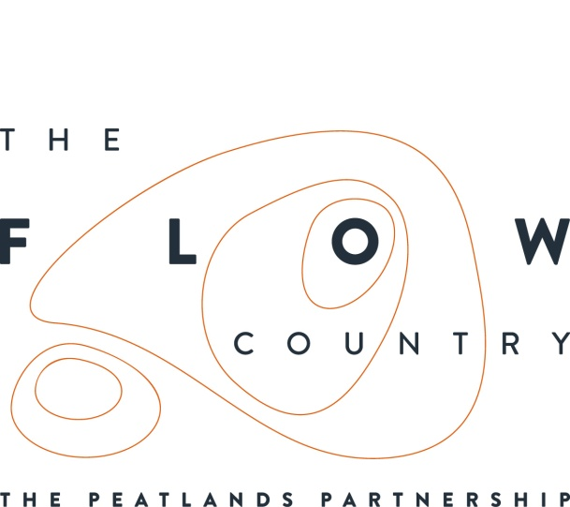

1st May 2018

A grand day out

A grand day out was had on a recent trip from Tongue, led by local historian Jim Johnson and artist Shaun Fraser from Inverness. This exposed the many layers of the local landscape, both above and below the ground.

Much of the morning was spent getting up close to peat on the Moine to the west of Tongue, exploring the detail and texture of the peat and its plants. This seemed particularly appropriate in a place whose name means peat. Shaun Fraser helped participants to produce plaster moulds of particular areas of peat and plants. After an initial hesitancy, everyone got stuck in and had great fun. It was rather like cooking a Beef Wellington using plaster and really highlighted the details of the bogs that are often overlooked. It was good to pause and look up close and see in particular the great variety of Sphagnum mosses, these being the plants that end up forming much of the peat.

Shaun also explained about the artwork he has been creating inspired by the Flow Country. This will be on show in the High Life Highland’s Thurso Galley from 15 September until the 27 October, alongside work by Hannah Imlach, another artist also commissioned by the Flows to the Future Project.

Shaun commented:

“It was fascinating to see how different people reflected on and responded to the landscape in which they live. It was also great to see how much they enjoyed working with tactile and unfamiliar materials.”

The day continued with a tour of the Kyle of Tongue, with Jim providing many more stories than can be related here, from the Jacobites to plans for creating polders. A particular highlight was visiting an impressive broch, complete with part of the original staircase that ran between the double walls.

Throughout the tour Jim highlighted how people would have used the local landscape, in particular the peat. An interesting discussion ensued on the many different ways of cutting the peat in different parts of the north. As well as being used as a fuel source, peat was also important in pre-Clearance times as a building material. Not only did it provide turfs for walls and roofs, but also the ancient bog wood provided roof crucks (timbers). The bog wood derives from a warmer spell some 4500 years ago which briefly allowed trees to grow on the bog.

It was also interesting to reflect on how attitudes to the landscape have changed. When Jim first wrote about the peatlands in the local newspapers 40 years ago, he was an advocate for digging them all up to fuel a power station, as has happened in areas of Ireland. He was however quickly told at that time about the special birds and plants that live on the bog. This was the period when huge swathes of peatland were disappearing under forestry. Another constant theme throughout the day was how the population has changed, with the Farr and Tongue parish having only 40% of the numbers it had in 1911.

The trip was part of the Heritage Lottery Fund supported Flows to the Future Project, see www.theflowcountry.org.uk. There is another opportunity to explore the Moine on Wednesday 16 May with a free High Life Highland Ranger walk, more details https://booking.highlifehighland.com/

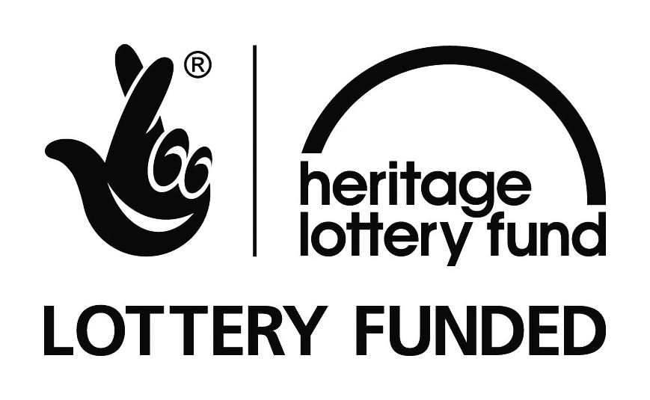

Photographs: Show people taking in part in the event. More are available.
NOTES TO EDITORS
The Peatlands Partnership includes Scottish Natural Heritage, Forestry Commission (Scotland), Highland Council, RSPB Scotland, Plantlife Scotland, Highlands & Islands Enterprise, The Highland Third Sector Interface, The Flow Country Rivers Trust, The Northern Deer Management Group and The Environmental Research Institute. It is chaired by Professor Stuart Gibb from the Environmental Research Institute, University of the Highlands and Islands.
RSPB Scotland is the lead partner in The Flows to the Future project, a Peatlands Partnership project, which gratefully acknowledges funding from the Heritage Lottery Fund and from the following funders and supporters; Environmental Research Institute, European Regional Development Fund, Forestry Commission (Scotland), Peatland Action, Highlands and Islands Enterprise, The Highland Council, RSPB, WREN, Scotland Rural Development Programme, Scottish Government, Scottish Natural Heritage and The Tubney Trust.

Peatlands cover less than 3% of the land surface of the Earth yet they contain twice as much carbon as the world’s forests. Huge areas of bog have been drained and damaged in the past, and the carbon that was locked in the peat for thousands of years is now rapidly being released to the atmosphere. Damaged peatlands are responsible for at least 10% of the world’s carbon dioxide emissions. Restoring peatlands is an effective and cost efficient way of reversing the carbon loss from damaged bogs.

CONTACT DETAILS
Caroline Eccles Project Manager - Flows to the Future Project, working on behalf of The Peatlands Partnership, c/o North Scotland Regional Office, Inverness. 01463 715000, Mobile 07590 441475 or caroline.eccles@rspb.org.uk
Ian Mitchell, Secretary, The Peatlands Partnership, c/o Scottish Natural Heritage: Tel 01408 634063 or peatlands_partnership@snh.gov.uk

